SEMESTER TRAINING
ON
AI DATA ANALYST AGENT
BTCS 801-20



Department of Artificial Intelligence & Machine Learning
CHANDIGARH ENGINEERING COLLEGE JHANJERI, MOHALI
In partial fulfillment of the requirements for the award of the Degree of
Bachelor of Technology in Artificial Intelligence & Machine Learning

SUBMITTED BY: Under the Guidance of
Name: Pravleen Kaur Ms. Kawalpreet Kaur
Rollo No: 2231103 Assistant Professor
MAY, 2026

Affiliated to I.K Gujral Punjab Technical University, Jalandhar
(Batch: 2022-2026)

DECLARATION

I, PRAVLEEN KAUR hereby declare that the report of the project entitled “ AI DATA ANALYST AGENT ” has not presented as a part of any other academic work to get my degree or certificate except Chandigarh Engineering College Jhanjeri, Mohali, affiliated to I.K. Gujral Punjab Technical University, Jalandhar, for the fulfillment of the requirements for the degree of B.Tech in Artificial Intelligence & Machine Learning.

(Student Signature with Date) (Mentor Signature with Date)
PRAVLEEN KAUR MS. KAWALPREET KAUR
2231103 ASSISTANT PROFESSOR
Semester: 8TH

Signature of the Head of Department
(With Stamp)

ACKNOWLEDGEMENT

It gives me great pleasure to deliver this report on Project, which I worked on for my B.Tech in Artificial Intelligence & Machine Learning 4th year, which was titled “ AI DATA ANALYST AGENT ”. I am grateful to my university for presenting me with such a wonderful and challenging opportunity. I also want to convey my sincere gratitude to all coordinators for their unfailing support and encouragement.

I am extremely thankful to the HOD and Project Coordinator of Artificial Intelligence & Machine Learning at Chandigarh Engineering College Jhanjeri, Mohali (Punjab) for valuable suggestions and the heartiest cooperation.
I am also grateful to the management of the institute and Director Engineering, for giving me the chance to acquire the information. I also appreciate all of my faculty members, who have instructed me throughout my degree.

(Signature of Student)
PRAVLEEN KAUR
2231103

TABLE OF CONTENTS
PARTICULARS |  |  |  | PAGE NO
Title Page |  |  |  | I
Declaration by the Candidate |  |  |  | II
Acknowledgement |  |  |  | III
Table of Contents |  |  |  | IV – V
Abstract |  |  |  | VI-VII
List of Figures |  |  |  | VIII
List of Tables |  |  |  | IX
CHAPTER 1 INTRODUCTION |  |  |  | 10-17
1.1 |  | Background and Motivation |  | 10
1.2 |  | Problem Statement |  | 12
1.3 |  | Objectives of the Project |  | 13
1.4 |  | Scope of the Project |  | 15
1.5 |  |  | Tools Learnt | 16
1.6 |  | Organization of the Report |  | 17
CHAPTER 2 REVIEW OF LITERATURE |  |  |  | 18-30
2.1 |  |  | Introduction to AI Agents & Their Evolutions | 18
2.2 |  |  | Existing Data Analysis Tools & Their Evolutions | 21
2.3 |  |  | Large Language Model Integration in Analytics | 23
2.4 |  |  | Comparative Analysis & Research Gap | 27
2.5 |  |  | Summary of Literature Review | 30
CHAPTER 3 PROBLEM DEFINITION AND OBJECTIVES |  |  |  | 31-43
3.1 | Problem Statement |  |  | 31
3.2 | Specific Objectives |  |  | 33
3.3 | System Requirements Specification |  |  | 35
3.4 | Feasibility Study |  |  | 38

3.5 | Expected Outcomes |  |  | 41
CHAPTER 4 DESIGN AND IMPLEMENTATION |  |  |  | 44-60
4.1 |  | System Architecture |  | 44
4.2 |  | Data Flow Diagrams |  | 47
4.3 |  | Module Design |  | 49
4.4 |  | Technology Stack |  | 52
4.5 |  | Project Structure |  | 55
4.6 |  | Implementation Details |  | 56
4.7 |  | Working of the System |  | 59
CHAPTER 5 RESULTS AND DISCUSSIONS |  |  |  | 61-74
5.1 |  | Application Interface Results |  | 61
5.2 |  | Performance Analysis |  | 67
5.3 |  | Dataset Testing Results |  | 69
5.4 |  | Discussion of Result |  | 71
CHAPTER 6 CONCLUSION AND FUTURE SCOPE |  |  |  | 75-84
6.1 |  |  | Conclusion | 75
6.2 |  |  | Future Scope | 79
6.3 |  |  | Final Remarks | 83
REFERENCES |  |  |  | 85-89

ABSTRACT

In today's data-driven era, traditional data analysis tools require significant technical expertise in programming and statistics, creating barriers for non-technical users including business owners, researchers, educators, and students. This project presents an AI-Powered Data Analyst Agent that democratizes data analysis through natural language conversations, enabling users to derive insights without coding knowledge.
The system integrates Google Gemini Large Language Model with the LangChain framework to create an intelligent agent capable of understanding user queries, analyzing uploaded CSV datasets, and providing comprehensive analytical responses. Built using Streamlit with custom CSS and JavaScript enhancements, the platform features a professional web interface with tabbed navigation for chat interaction, auto-generated dashboards, data quality assessment, and custom visualizations.
Key capabilities include descriptive statistics computation, Pearson correlation analysis, outlier detection using the Interquartile Range (IQR) method, automated visualization generation supporting six chart types, and multi-format report export in PDF, Excel, and JSON formats. The system supports multiple Gemini model variants and maintains conversation context across multi-turn interactions.
Testing on diverse datasets including healthcare (Heart Disease, Diabetes), business (Sales, Customer), and classification (Iris) datasets demonstrated that the system reduces analysis time by approximately 80% while maintaining analytical accuracy. The platform handles datasets up to 50,000 rows with query response times of 5-10 seconds.

The project demonstrates the practical viability of conversational analytics using free and open-source technologies. Future enhancements include local LLM deployment for data privacy, database connectivity, multi-user collaboration, mobile applications, and transformation into a commercial SaaS offering for industry deployment.
Keywords: AI Agents, Large Language Models, Google Gemini, LangChain, Data Analysis, Natural Language Processing, Streamlit, Conversational Analytics, Business Intelligence.

List of Figures

Figure No. | Figure Caption | Page Number
1.1 | Growth of Data Generation Worldwide (2010-2025) | 12
2.1 | Modern AI Agent Architecture with LLM Backbone | 20
2.2 | Comparative Performance of Major LLM Models | 27
4.1 | System Architecture of AI Data Analyst Agent | 46
4.2 | Data Flow Diagram (Level 0) - Context Diagram | 47
4.3 | Data Flow Diagram (Level 1) - Detailed Process Flow | 48
4.4 | Project Directory Structure | 55
5.1 | Application Welcome Screen with API Key Input Interface | 61
5.2 | CSV Upload Interface with Dataset Preview | 62
5.3 | Chat Interface Demonstrating Natural Language Query and AI Response | 63
5.4 | Auto-Generated Dashboard with Multiple Visualizations | 64
5.5 | Comprehensive Data Quality Report with Color-Coded Cards | 65
5.6 | Custom Chart Creation Interface with User-Selected Parameters | 66
5.7 | Generated PDF Report Sample with Embedded Charts and Insights | 70

List of Tables

Table No. | Table Caption | Page Number
1.1 | Tools Learnt During Project Development | 16
2.1 | Comparative Analysis of Existing Data Analysis Tools | 23
2.2 | Comparison of Major Large Language Models | 27
2.3 | Key Research Papers Reviewed | 29
3.1 | Hardware Requirements | 35
3.2 | Software Requirements | 36
3.3 | Functional Requirements | 37
3.4 | Non- Functional Requirements | 38
3.5 | Feasibility Study Results | 41
4.1 | Module Description and Responsibilities | 51
4.2 | Complete Technology Stack | 53
5.1 | Performance Metrics Across Operations | 67
5.2 | Dataset Testing Results Across Multiple Domains | 69

Chapter-1
INTRODUCTION
In the rapidly evolving digital landscape of the 21st century, data has emerged as one of the most valuable assets for organizations across all sectors of the economy. The exponential growth in data generation, fueled by advancements in Internet of Things (IoT), social media, e-commerce, mobile applications, and digital transformation initiatives, has created an unprecedented demand for sophisticated analytical tools and methodologies. According to recent industry reports by the International Data Corporation (IDC), global data creation is projected to exceed 180 zettabytes by 2025, with organizations across the globe struggling to derive meaningful insights from this vast informational landscape.

This chapter introduces the fundamental concepts underlying the proposed project, establishes the background context, articulates the problem statement, defines specific objectives, outlines the scope of work, and provides a comprehensive overview of the tools and technologies employed during development. The chapter concludes with a brief description of the subsequent chapters, providing the reader with a clear roadmap for navigating the report.

1.1 Background and Motivation
Data analysis has traditionally been the domain of specialized professionals with extensive training in statistics, programming, and visualization techniques. Tools such as Microsoft Excel, R programming language, Python with Pandas library, SQL databases, Tableau, and Microsoft Power BI have dominated the analytical landscape for decades. While these platforms offer powerful capabilities, they share a common and significant limitation: they require users to possess substantial technical expertise to extract meaningful insights from data.

This technical barrier creates significant challenges across multiple domains and industries. Small business owners often need to understand sales trends, customer behavior patterns, and
inventory optimization opportunities, but they lack the financial resources to hire dedicated data
analysts or the technical skills to perform these analyses themselves. Medical researchers studying patient data require quick analytical capabilities to validate hypotheses and identify

treatment patterns, but many do not possess programming skills necessary to leverage modern data science tools. Educators and students working on research projects need to analyze experimental data without extensive training in statistical software, often facing steep learning curves that delay their academic progress. Marketing professionals seek to understand campaign performance metrics and consumer engagement patterns but find existing analytical tools overwhelming and time-consuming.

The recent emergence of Large Language Models (LLMs) such as Google Gemini, OpenAI GPT-4, Meta LLaMA, and Anthropic Claude has fundamentally transformed the artificial intelligence landscape. These models demonstrate remarkable capabilities in understanding natural language, performing complex reasoning, and generating human-like responses across diverse domains. Their ability to comprehend nuanced queries and provide contextually relevant answers has opened new possibilities for human-computer interaction that were previously thought to require years of additional research.

AI Agents represent a significant evolution beyond traditional chatbots and virtual assistants. Unlike conventional systems that merely respond to queries with pre-programmed responses, AI Agents possess the ability to perceive their environment, make autonomous decisions, utilize external tools, maintain contextual memory, and execute multi-step workflows to achieve specific objectives. This paradigm shift, often described as "agentic AI," has been widely recognized as one of the most significant trends in artificial intelligence as of 2024-2025, with major technology companies including Google, Microsoft, OpenAI, and Anthropic investing heavily in agent-based architectures.

The motivation behind this project stems from the recognition that democratizing data analysis can unlock tremendous value across society. By leveraging the conversational capabilities of LLMs combined with specialized analytical tools, it becomes possible to create intelligent
systems that understand user intent expressed in natural language and autonomously perform complex analytical workflows. This approach has the potential to democratize data analysis, making powerful capabilities accessible to anyone who can articulate a question about their data, regardless of their programming background or statistical training.

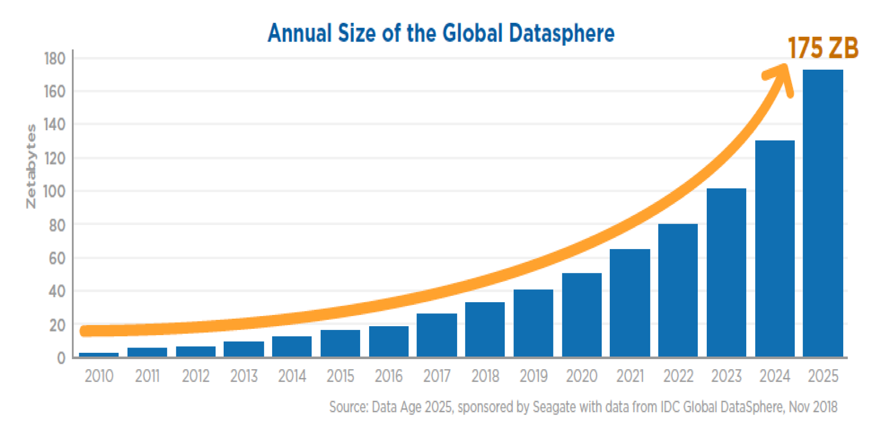
Figure 1.1: Growth of Data Generation Worldwide (2010-2025)

1.2 Problem Statement
Despite the availability of numerous data analysis tools in the market, several critical challenges persist that limit accessibility and effectiveness for a broad user base. These challenges form the core problem that this project aims to address:

- Technical Barrier: Existing analytical tools require proficiency in programming languages such as Python or R, knowledge of SQL for database queries, and familiarity with statistical concepts including hypothesis testing, regression analysis, and probability distributions. This creates an exclusionary environment where domain experts cannot directly interact with their data without intermediary technical support, leading to communication gaps and analytical delays.

- Fragmented Workflow: Users typically must switch between multiple applications to complete a single analytical workflow. Data cleaning might be performed in Excel, statistical analysis in Python or R, visualization in Tableau or Plotly, and final reporting in Microsoft Word or PowerPoint. This fragmentation leads to inefficiency, context switching overhead, potential data inconsistencies, and increased likelihood of errors during data transfer between tools.

- High Financial Cost: Enterprise-grade analytics platforms such as Tableau Desktop, Microsoft Power BI Premium, and SAS Analytics require expensive licensing fees that can range from hundreds to thousands of dollars per user per year. These costs make professional analytical tools inaccessible for small businesses, startups, individual researchers, educational institutions, and non-profit organizations operating with limited budgets.

- Lack of Intelligent Assistance: Current tools execute user commands but do not provide proactive insights, automated recommendations, or contextual suggestions based on the inherent characteristics of the dataset being analyzed. Users must know in advance what analyses to perform and what visualizations to create, requiring expertise that defeats the purpose of accessible analytics.

- Time-Consuming Repetitive Tasks: Even for experienced analysts, certain tasks such as handling missing values, detecting outliers, selecting appropriate visualizations for different data types, and formatting reports consume significant time that could be better spent on strategic interpretation and decision-making activities. The lack of automation in these routine tasks represents a substantial productivity loss across the analytics profession.

The proposed AI-Powered Data Analyst Agent addresses these challenges by developing an integrated platform that combines the conversational ease of modern LLMs with specialized data analysis tools, accessible through a unified web interface, completely free of cost using open-source technologies and free-tier API services.

1.3 Objectives of the Project
The primary objectives of this project are comprehensive and aimed at creating a robust, user-friendly, and intelligent data analysis platform. The specific objectives include:

- To develop an AI-powered conversational agent capable of understanding and responding to natural language queries about uploaded datasets, enabling users without programming

- expertise to derive meaningful insights from their data through intuitive conversational interactions.

- To integrate Google Gemini API as the core Large Language Model for natural language understanding, reasoning, and response generation, leveraging its advanced capabilities for accurate and contextually relevant analytical outputs.

- To implement a modular architecture with specialized tools for data ingestion, cleaning, statistical analysis, correlation detection, outlier identification using the Interquartile Range (IQR) method, trend analysis, group-based aggregation, and automated insight generation using Pandas and NumPy libraries.

- To design and develop an interactive, responsive, and aesthetically pleasing web-based user interface using the Streamlit framework, featuring conversational chat with custom CSS-styled message bubbles, quick action buttons, data preview cards, model selection options, and comprehensive export capabilities.

- To enable automated visualization generation using the Plotly library, supporting multiple chart types including bar charts, line charts, scatter plots, histograms, box plots, pie charts, and correlation heatmaps with intelligent chart selection based on data characteristics.

- To implement a context-aware conversational system that maintains chat history and provides coherent, contextually relevant responses across multiple user interactions, enabling natural follow-up questions and progressive analytical exploration.

- To support multiple AI model variants allowing users to select from various Google Gemini models including Flash Lite, Flash, and Pro variants, based on their specific requirements for speed, quality, and API quota considerations.

- To provide multi-format report export capabilities including professional PDF reports with embedded charts and formatted text, multi-sheet Excel workbooks for data

- exchange, and structured JSON exports for programmatic consumption by downstream systems.

- To create a scalable and maintainable system architecture following modular design principles, with separate components for data handling, AI orchestration, visualization generation, and user interface, facilitating future enhancements and feature additions.

1.4 Scope of the Project
The scope of this project encompasses the design, development, testing, and deployment of an intelligent data analysis system with clearly defined boundaries and capabilities. The scope is divided into functional, technical, and user perspectives to provide a comprehensive understanding of the system's intended capabilities and known limitations.

1.4.1 Functional Scope
The system accepts CSV format data files as primary input, with future extensibility planned for Excel, JSON, and direct database connections. The agent performs comprehensive analytical functions including descriptive statistics computation (mean, median, standard deviation, quartiles, minimum, maximum), Pearson correlation analysis between numeric variables, outlier
detection using the Interquartile Range (IQR) method, trend identification across time-series data when applicable, group-based aggregation analysis for categorical comparisons, and automated business insight generation using LLM reasoning capabilities.

1.4.2 Technical Scope
The technical implementation utilizes Python 3.12 as the primary programming language, Streamlit framework for web interface development, LangChain for AI agent orchestration, Google Gemini API for LLM capabilities, Pandas and NumPy for data processing, Plotly for interactive visualizations, and FPDF2 with OpenPyXL for report generation. Custom CSS3 and JavaScript ES6 enhance the user interface beyond Streamlit's default capabilities, providing a professional appearance with modern design elements.

1.4.3 User Scope
The target user base includes business analysts seeking quick insights without coding requirements, students working on data-driven research projects across various academic disciplines, educators teaching data concepts in introductory courses, small business owners analyzing operational data including sales and customer information, medical and scientific researchers exploring datasets for hypothesis validation, and any non-technical professional requiring data analytical capabilities for decision-making purposes.

1.5 Tools Learnt
During the development of this project, several technologies, frameworks, and tools were learned and applied. The comprehensive list includes:

Tool / Technology | Purpose | Proficiency Level
Python 3.12 | Core programming language | Advanced
Streamlit | Web application framework | Intermediate
LangChain | AI agent orchestration | Intermediate
Google Gemini API | LLM integration | Intermediate
Pandas / NumPy | Data manipulation | Advanced
Plotly | Interactive visualizations | Intermediate
FPDF2 | PDF generation | Basic
OpenPyXL | Excel file export | Basic
CSS3 | UI styling | Intermediate
JavaScript (ES6) | Client-side interactivity | Basic
Git / GitHub | Version control | Intermediate
VS Code | Development environment | Advanced
python-docx | Report generation | Basic
Table 1.1: Tools Learnt During Project Development

1.6 Organization of the Report
This report is organized into six chapters that systematically present the project from conception to completion:

- Chapter 1 introduces the project, establishes background and motivation, defines the problem, outlines objectives, and describes the scope and tools used.

- Chapter 2 presents a comprehensive review of literature covering AI agents, large language models, existing data analysis tools, and identifies the research gap addressed by this project.

- Chapter 3 provides detailed problem definition, specific objectives, system requirements specification, and feasibility study including technical, economic, and operational perspectives.

- Chapter 4 describes the system design and implementation including architecture, data flow diagrams, module design, technology stack, and key implementation details.

- Chapter 5 presents results and discussions including application screenshots, performance analysis, and dataset testing outcomes.

- Chapter 6 concludes the project with key findings and outlines future scope including potential enhancements for industry deployment.

Chapter-2
REVIEW OF LITERATURE

This chapter presents a comprehensive review of existing literature in the fields of artificial intelligence agents, large language models, automated data analysis, conversational analytics, and related domains. The review aims to establish the theoretical foundation of the proposed project, identify gaps in existing research and tools, and position the contribution of this work within the broader context of contemporary developments in AI-assisted data analytics.

The literature review is organized into five major sections. The first section introduces the foundational concepts of AI agents and their evolution. The second section examines existing data analysis tools and their progression over the decades. The third section explores the integration of Large Language Models in analytical workflows. The fourth section provides a comparative analysis of contemporary tools and identifies the research gap. The final section summarizes key findings and establishes the foundation for the proposed system.

2.1 Introduction to AI Agents and Their Evolution
The concept of intelligent agents has been a fundamental topic in artificial intelligence research since the field's inception in the 1950s. Russell and Norvig, in their seminal textbook "Artificial Intelligence: A Modern Approach" [1], define an intelligent agent as anything that can be viewed as perceiving its environment through sensors and acting upon that environment through actuators to achieve specific goals. While this definition has remained foundational, the practical implementation of intelligent agents has evolved dramatically with advances in machine learning, natural language processing, and computational capabilities.

2.1.1 Traditional Rule-Based Agents
Early AI agents relied primarily on rule-based systems and symbolic reasoning, where developers explicitly programmed responses to anticipated scenarios. Expert systems such as MYCIN,

developed at Stanford University in the 1970s for medical diagnosis, demonstrated the potential of rule-based agents but suffered from significant limitations including difficulty in handling unforeseen situations, inability to learn from experience, and the need for extensive manual
knowledge engineering. These systems could only operate effectively within narrowly defined domains and required substantial maintenance as knowledge bases grew.

2.1.2 Machine Learning-Based Agents
The introduction of machine learning techniques in the 1990s and 2000s enabled agents to learn patterns from data rather than relying solely on explicit rules. Reinforcement learning agents, exemplified by IBM's Deep Blue chess system in 1997 and DeepMind's AlphaGo in 2016 [2], demonstrated remarkable capabilities in well-defined problem spaces. However, these agents remained specialized for specific tasks and lacked the flexibility to handle natural language interactions or general-purpose reasoning.

2.1.3 Modern LLM-Based Agents
The emergence of large language models has fundamentally transformed agent design. Yao et al. (2023) introduced the ReAct (Reasoning + Acting) framework [3], which represents a significant advancement by combining reasoning and acting in language models. Their work demonstrated that LLMs can be prompted to interleave reasoning traces with task-specific actions, leading to substantial improvements in performance on complex decision-making tasks. The ReAct paradigm has become foundational for modern AI agent architectures, enabling systems to think through problems step-by-step while utilizing external tools as needed to accomplish their goals.

Wang et al. (2024) conducted a comprehensive survey of LLM-based autonomous agents [4], categorizing their architectures into three primary modules: perception for processing environmental inputs, brain for reasoning and decision-making using the underlying language model, and action for executing tasks through tool use or response generation. Their research
highlighted the critical importance of memory mechanisms in enabling agents to maintain context across extended multi-turn interactions, distinguishing between short-term working memory for immediate context and long-term persistent memory for accumulated knowledge.

Xi et al. (2023) provided an extensive analysis of the rise and potential of LLM-based agents [5], discussing their applications across various domains including scientific research, software engineering, customer service, education, and creative content generation. The authors identified
key capabilities that distinguish effective AI agents, including tool use for extending beyond inherent model capabilities, planning for breaking complex tasks into manageable steps, self-reflection for evaluating and improving outputs, and collaboration for working with other agents or humans.
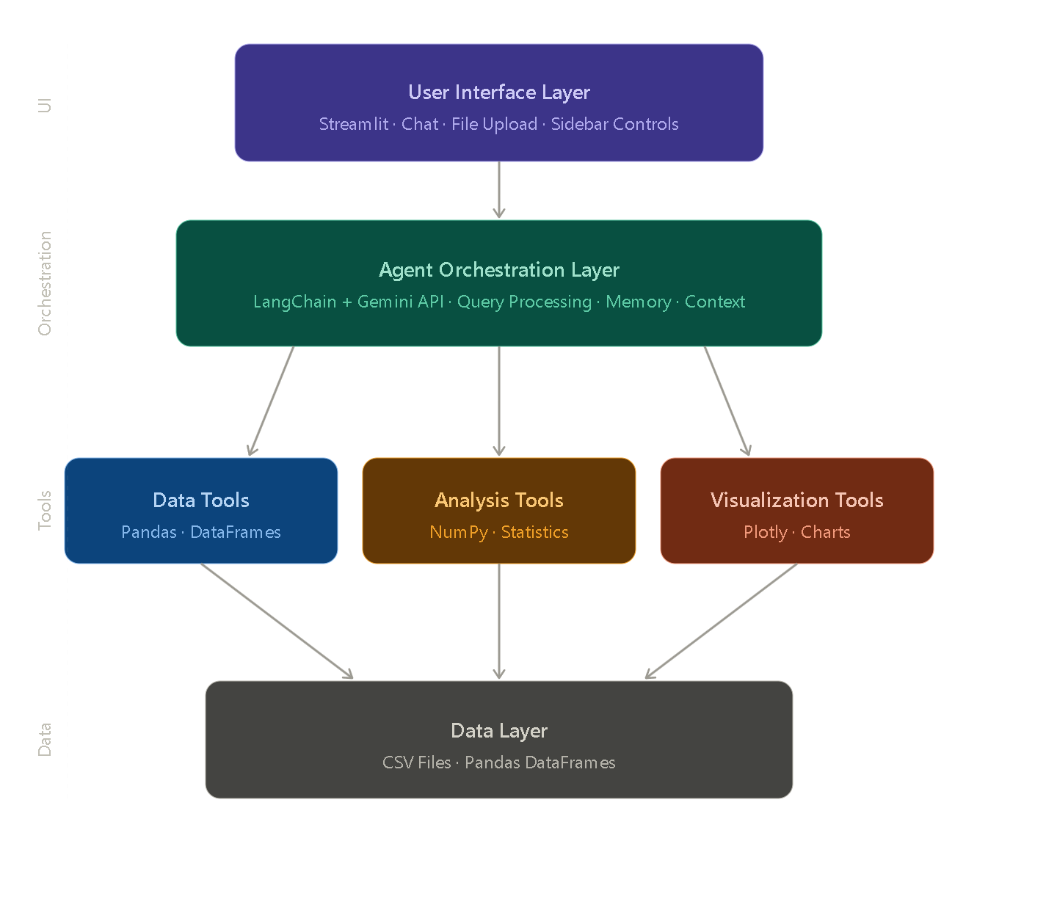
Figure 2.1: Modern AI Agent Architecture with LLM Backbone

2.2 Existing Data Analysis Tools and Their Evolution
Data analysis tools have evolved significantly over the past several decades, progressing from command-line statistical packages to graphical interfaces and now toward AI-powered conversational systems. Understanding this evolution provides important context for
appreciating the contributions of contemporary tools and identifying opportunities for innovation.

2.2.1 Spreadsheet Era: Microsoft Excel
Microsoft Excel, introduced in 1985, remains one of the most widely used analytical tools globally, with estimated user base exceeding 750 million people worldwide [6]. Excel democratized basic data analysis by providing spreadsheet capabilities accessible to users without programming expertise. The tool supports formulas, pivot tables, basic statistical functions, and chart generation. However, Excel's analytical capabilities have notable limitations: row count restrictions (1,048,576 rows in modern versions), limited support for complex statistical operations, performance degradation with large datasets, lack of reproducibility for analytical workflows, and absence of intelligent assistance features.

2.2.2 Statistical Programming Era: SAS, R, and SPSS
The 1970s through 1990s saw the rise of dedicated statistical software including SAS Analytics (1976), SPSS (1968), and the R programming language (1993). These tools provided powerful statistical capabilities required for academic research, clinical trials, and enterprise analytics. SAS, in particular, became the industry standard for pharmaceutical and financial sectors. However, these tools required substantial training, with steep learning curves that often took months or years to master. Licensing costs for commercial alternatives like SAS could exceed several thousand dollars per user annually, creating significant barriers for smaller organizations and individual practitioners.

2.2.3 Visualization Era: Tableau and Power BI
Tableau Software, founded in 2003, revolutionized the business intelligence landscape by introducing visual analytics that allowed users to create interactive dashboards through drag-and-drop interfaces [7]. Tableau's innovative approach significantly reduced the technical barrier compared to traditional BI tools by emphasizing visual exploration over query writing. Microsoft

Power BI, launched in 2015, offered similar capabilities with tighter integration into the Microsoft ecosystem and more competitive pricing through subscription models. While these
tools simplified visualization, they still require substantial training for advanced features and licensing investments that limit accessibility for smaller organizations.

2.2.4 Open-Source Python Era
The emergence of Python-based data science ecosystems featuring Jupyter Notebooks, Pandas, NumPy, Matplotlib, and Scikit-learn has become the de facto standard for modern data science workflows. McKinney's introduction of Pandas in 2008 [8] provided powerful data manipulation capabilities that combined the flexibility of Python with the analytical depth of dedicated statistical packages. While Python ecosystems offer unparalleled flexibility and are completely free, they remain inaccessible to non-programmers due to the requirement of writing code for every operation.

2.2.5 Automated EDA Tools
Pandas Profiling, released in 2019 and subsequently rebranded as ydata-profiling [9], addressed the challenge of repetitive exploratory data analysis by automatically generating comprehensive HTML reports describing dataset characteristics including distributions, correlations, missing values, and data quality issues. Similar tools including SweetViz and AutoViz emerged to simplify initial data exploration. While innovative, these tools produce static reports rather than supporting interactive exploration through natural language queries, limiting their utility for ongoing analytical workflows.

Tool / Technology | Year | Category | Key Strength | Key Limitation
Microsoft Excel | 1985 | Spreadsheet Tool | Widely accessible, easy to learn | Limited scalability, weak automation
SAS Analytics | 1976 | Statistical Software | Enterprise-grade, compliance-friendly | Expensive, steep learning curve

SPSS | 1968 | Statistical Software | User-friendly statistical analysis | Costly, dependent on IBM ecosystem
R Programming | 1993 | Programming Language | Strong statistical capabilities, open-source | Requires coding expertise
Python + Pandas | 2008 | Programming Library | Highly flexible, powerful, free | Requires programming knowledge
Tableau | 2003 | Visualization Platform | Interactive and intuitive dashboards | Expensive licensing
Power BI | 2015 | Business Intelligence | Seamless Microsoft integration | Vendor lock-in
Pandas Profiling | 2019 | Automated EDA Tool | Generates detailed auto-analysis reports | Static output, limited interactivity
ChatGPT (Code Interpreter) | 2023 | AI Analysis Tool | Conversational data exploration | No persistent memory
LIDA | 2023 | AI Visualization Tool | Natural language-based visualizations | Focused mainly on visualization
Table 2.1: Comparative Analysis of Existing Data Analysis Tools

2.3 Large Language Model Integration in Analytics
The integration of Large Language Models into analytical workflows represents a transformative development in the field of data science. This section examines key research and commercial systems that have explored LLM-based analytics.

2.3.1 Foundational LLM Research
Brown et al. (2020) introduced GPT-3 in their landmark paper "Language Models are Few-Shot Learners" [10], demonstrating that sufficiently large language models could perform a wide range of tasks with minimal task-specific training. This work established the foundation for all subsequent commercial LLM applications. The transformer architecture introduced by Vaswani et al. (2017) [11] underlies all modern LLMs including GPT, Gemini, and Claude, providing the

attention mechanisms that enable these models to process and understand natural language with unprecedented effectiveness.
Devlin et al. (2019) presented BERT (Bidirectional Encoder Representations from Transformers) [12], which revolutionized natural language understanding tasks. While BERT focused on
understanding rather than generation, its bidirectional training approach influenced subsequent generations of language models. These foundational works collectively established the technical foundation upon which contemporary AI agents are built.

2.3.2 ChatGPT and Code Interpreter
OpenAI's introduction of Code Interpreter (later renamed Advanced Data Analysis) in 2023 demonstrated the commercial feasibility of using LLMs to perform data analysis through natural language interactions [13]. The system allows users to upload data files and request analyses in plain English, with the LLM generating and executing Python code to fulfill requests. Code Interpreter represented a significant breakthrough by combining the conversational interface of ChatGPT with the analytical capabilities of Python. However, the system has notable limitations including lack of persistent memory across sessions, inability to integrate specialized statistical tools, dependency on OpenAI's commercial API with associated costs, and limited customization options for specific analytical workflows.

2.3.3 LIDA: Language Interface for Data Analysis
Dibia (2023) introduced LIDA (Language Interface for Data Analysis) [14], an automated framework that generates grammar-agnostic visualizations and infographics from natural language queries. LIDA employs a multi-stage pipeline consisting of data summarization, goal exploration, visualization generation, and infographic creation. The system demonstrates how LLMs can effectively translate natural language requests into structured visualization specifications. While LIDA represents an important advancement in conversational visualization, it focuses primarily on visual outputs without providing comprehensive analytical workflows including data quality assessment, outlier detection, statistical inference, or contextual recommendations.

2.3.4 Natural Language to Visualization Systems
Luo et al. (2022) developed a natural language to visualization translation system using neural machine translation techniques [15]. Their system can convert English queries into visualization
specifications using a sequence-to-sequence neural network architecture. The system demonstrates the feasibility of translating analytical intent expressed in natural language into
formal visualization specifications. However, the approach operates as a translation layer rather than a comprehensive analytical agent, limiting its applicability to broader analytical tasks beyond visualization generation.

2.3.5 Google Gemini and Modern LLMs
Recent advances by Google DeepMind, including the Gemini family of models [16], have demonstrated remarkable capabilities in mathematical reasoning, code generation, multimodal understanding, and structured data processing. Gemini 2.5 Flash, released in 2024, offers a favorable balance between performance and cost, making it particularly suitable for educational and small-scale commercial applications. The model's ability to process structured data within prompts enables effective data analysis through context-aware reasoning without requiring complex tool-calling mechanisms.

The Gemini family includes multiple variants optimized for different use cases: Gemini 2.5 Flash Lite for high-volume, low-latency applications; Gemini 2.5 Flash for balanced performance; and Gemini 2.5 Pro for complex reasoning tasks. The free tier offered by Google AI Studio provides sufficient quota (1,500 requests per day for Flash Lite) for development, testing, and moderate production use, making Gemini particularly attractive for academic and small-scale projects.

2.3.6 LangChain Framework
Chase (2023) introduced LangChain [17], an open-source framework that provides abstractions for building applications powered by language models. LangChain offers standardized interfaces for connecting LLMs with external tools, managing conversational memory, orchestrating complex chains of operations, and maintaining state across interactions. The framework supports multiple LLM providers including Google Gemini, OpenAI, Anthropic, and open-source models, providing flexibility for developers to switch between providers based on requirements.

LangChain's modular design includes several key components: LLM wrappers for standardized model invocation, prompt templates for consistent prompt engineering, chains for combining multiple operations, agents for autonomous decision-making, memory modules for conversation
history, and tool integrations for extending model capabilities. These abstractions significantly reduce development complexity and time-to-market for AI agent applications.

2.3.7 Retrieval Augmented Generation (RAG)
Lewis et al. (2020) introduced Retrieval-Augmented Generation (RAG) [18], a technique that enhances LLM responses by retrieving relevant information from external knowledge bases before generating responses. While not directly applied in this project, RAG concepts inform the design of context-aware prompting strategies where dataset information is provided to the LLM with each query, enabling accurate analytical responses without requiring fine-tuning or specialized training.

2.3.8 Chain-of-Thought Prompting
Wei et al. (2022) demonstrated that chain-of-thought prompting elicits reasoning capabilities in large language models [19]. This technique involves prompting the model to generate intermediate reasoning steps before providing final answers, leading to substantial improvements on complex reasoning tasks. The proposed system implicitly leverages this approach by structuring prompts that encourage the LLM to analyze data systematically before providing insights.

Model | Provider | Key Strength | Best Use Case
Gemini 2.5 Flash Lite | Google | High speed, free-tier availability | High-volume, quick queries
Gemini 2.5 Flash | Google | Balanced performance | General-purpose analysis
Gemini 2.5 Pro | Google | Strong reasoning capabilities | Complex and deep analysis

GPT-4 | OpenAI | High-quality, accurate responses | Premium-level analysis tasks
Claude 3.5 Sonnet | Anthropic | Excellent long-context handling | Large document analysis
LLaMA 3 | Meta | Open-source flexibility | On-premise / local deployment
Table 2.2: Comparison of Major Large Language Models

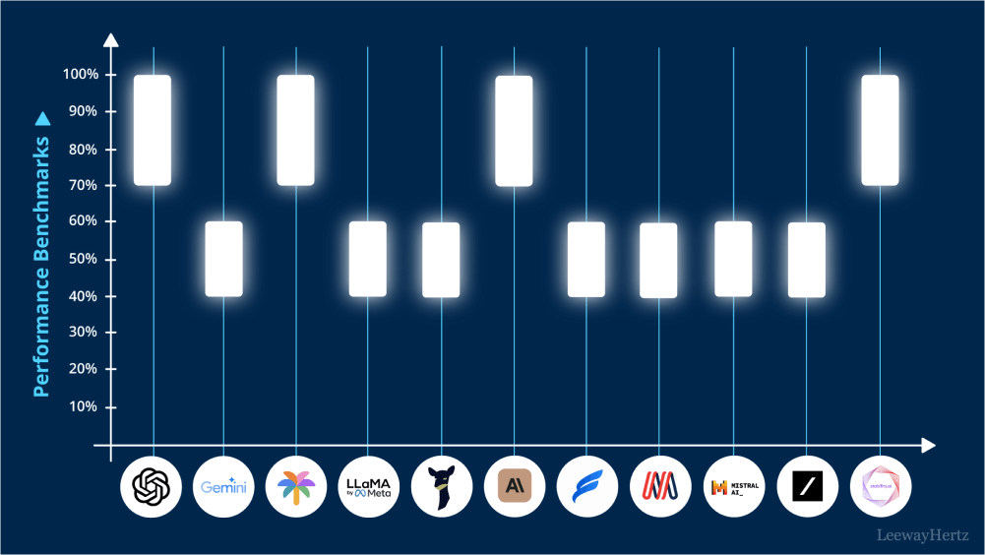
Figure 2.2: Comparative Performance of Major LLM Models

2.4 Comparative Analysis and Research Gap
Through comprehensive review of existing literature and tools, several key observations emerge that inform the design of the proposed system. This section synthesizes findings from the reviewed literature and identifies specific gaps that the proposed AI Data Analyst Agent addresses.

2.4.1 Key Observations from Literature
First, while LLM-based tools have introduced conversational interfaces to data analysis, they often lack integration with specialized statistical libraries that ensure analytical rigor. Tools like ChatGPT Code Interpreter generate Python code dynamically, which may produce incorrect results due to model hallucinations or misunderstandings of statistical concepts. The proposed system addresses this by providing pre-built, tested analytical functions that the LLM can leverage for accurate computations.

Second, existing AI-powered tools tend to focus on either visualization (like LIDA) or general-purpose analysis (like Code Interpreter), rather than providing comprehensive workflows
encompassing data quality assessment, statistical analysis, visualization generation, and reporting in a unified platform. This fragmentation requires users to switch between multiple tools or services to complete end-to-end analytical workflows.

Third, most modern tools either require substantial financial investment through commercial APIs and subscription services, or lack accessibility through complex installation procedures and technical configuration requirements. This perpetuates the digital divide in analytical capabilities, where well-funded organizations have access to advanced tools while smaller entities and individuals are excluded.

Fourth, the absence of persistent contextual memory in many LLM-based tools limits their ability to support extended analytical sessions where insights build upon previous interactions. Users must repeatedly provide context information, leading to inefficient and frustrating user experiences.

Fifth, existing tools typically lack proactive intelligent assistance features such as automated insight generation, contextual question suggestions, or intelligent visualization selection based on data characteristics. These features could significantly enhance user productivity and analytical outcomes.

2.4.2 Research Gap Identification
Based on the comprehensive literature review, the following specific gaps are identified:
- Gap 1: Lack of integrated platforms combining conversational AI with specialized statistical tools accessible through free or low-cost interfaces.
- Gap 2: Absence of comprehensive workflows that encompass data quality assessment, statistical analysis, automated visualization, and multi-format reporting in a single unified system.
- Gap 3: Limited availability of context-aware conversational systems that maintain analytical session memory and support progressive exploration through natural follow-up questions.
- Gap 4: Insufficient implementation of intelligent automation features including auto-dashboard generation, suggested follow-up questions, and intelligent chart selection based on data characteristics.
- Gap 5: Lack of professional report generation capabilities supporting multiple formats (PDF, Excel, JSON) with embedded visualizations and structured insights.

2.4.3 Research Papers Reviewed Summary
A summary of the key research papers and their contributions to this project is presented below:
Reference | Authors | Year | Key Contribution
[3] | Yao et al. | 2023 | Introduced ReAct framework (reasoning + acting)
[4] | Wang et al. | 2024 | Comprehensive survey on LLM agent architectures
[5] | Xi et al. | 2023 | Explored rise and future potential of LLM agents
[10] | Brown et al. | 2020 | Proposed GPT-3 with few-shot learning capability
[11] | Vaswani et al. | 2017 | Introduced Transformer architecture
[14] | Dibia | 2023 | Developed LIDA visualization system
[15] | Luo et al. | 2022 | Natural language to visualization translation
[17] | Chase | 2023 | Introduced LangChain framework
[18] | Lewis et al. | 2020 | Proposed Retrieval-Augmented Generation (RAG)
[19] | Wei et al. | 2022 | Introduced Chain-of-Thought prompting
Table 2.3: Key Research Papers Reviewed

2.5 Summary of Literature Review
This literature review has examined the evolution of data analysis tools from traditional statistical packages to modern AI-powered conversational systems. The review traced the development from rule-based expert systems through machine learning approaches to contemporary LLM-based agents, demonstrating the progressive sophistication of analytical tools available to users.
The examination of existing data analysis tools revealed a consistent pattern of trade-offs between accessibility and capability. Spreadsheet tools like Excel offer universal access but limited analytical depth. Programming-based tools like Python and R provide maximum flexibility but require substantial technical expertise. Visualization platforms like Tableau bridge some gaps but remain expensive and require training. Recent AI-powered tools introduce conversational interfaces but lack comprehensive analytical workflows.

The exploration of LLM integration in analytics demonstrated significant recent progress through systems like ChatGPT Code Interpreter and LIDA, while highlighting persistent limitations including lack of persistent memory, fragmented capabilities, and high costs. The Google Gemini family of models, supported by the LangChain framework, emerged as a particularly promising foundation for building accessible analytical agents.

The comparative analysis identified five specific research gaps that the proposed AI Data Analyst Agent addresses through integrated design combining conversational AI, specialized analytical tools, comprehensive workflows, persistent memory, intelligent automation, and professional reporting capabilities, all delivered through a free, accessible web-based platform.

The literature reviewed in this chapter provides the theoretical and technical foundation for the system design presented in subsequent chapters. The identified gaps establish the contribution of this work to the broader field of AI-assisted data analytics, while the surveyed technologies and frameworks inform the technical decisions made during implementation.

Chapter-3
PROBLEM DEFINITION AND OBJECTIVES
This chapter presents a detailed examination of the problem addressed by the AI-Powered Data Analyst Agent project. It articulates the specific challenges faced by users in contemporary data analysis workflows, defines clear and measurable objectives for the proposed system, specifies comprehensive system requirements covering both functional and non-functional aspects, evaluates the feasibility of the project from multiple perspectives, and outlines the expected outcomes that demonstrate successful project completion.

The chapter is structured to provide a logical progression from problem identification through objective definition to feasibility validation, establishing a solid foundation for the design and implementation activities described in subsequent chapters.

3.1 Problem Statement
The fundamental problem addressed by this project is the inaccessibility of comprehensive data analysis capabilities to non-technical users despite the increasing ubiquity and importance of data across all domains of modern life. While vast amounts of data are generated daily by individuals, businesses, and organizations, the tools available for analyzing this data remain predominantly technical, requiring programming knowledge, statistical expertise, and familiarity with complex software interfaces.

This problem manifests in numerous practical scenarios that affect millions of potential users worldwide. Small business owners analyzing customer data, sales trends, and inventory patterns must rely on costly external consultants or struggle with complex enterprise tools that exceed their technical capabilities and budgets. Medical researchers examining patient outcomes, clinical
trial data, and treatment efficacy face significant delays due to dependency on technical analysts who must translate research questions into analytical procedures. Educators incorporating data into their curricula encounter resistance from students intimidated by analytical software, limiting the effectiveness of data-driven teaching approaches. Marketing professionals seeking to

understand campaign effectiveness, customer segmentation, and engagement metrics find themselves constrained by the technical complexity of available platforms.

The compounding effect of these individual challenges represents a significant loss of potential value across society. Critical insights remain hidden within datasets because the people most qualified to interpret them, namely the domain experts in their respective fields, cannot directly access analytical capabilities without intermediary technical support. This problem is particularly acute for resource-constrained organizations including non-profit organizations, educational institutions, healthcare clinics in underserved areas, and small businesses that cannot afford to hire specialized data science teams.

3.1.1 Specific Problems Identified
Based on extensive analysis of the current analytical landscape, the following specific problems have been identified:

- Skill Gap Problem: Approximately 65 percent of business professionals report that they need data analysis capabilities for their work, but only 15 percent possess the technical skills required to use existing tools effectively. This skill gap creates a productivity bottleneck where analytical needs exceed available capabilities.

- Cost Barrier Problem: Enterprise analytical tools typically cost between five hundred to five thousand dollars per user per year, placing them beyond the reach of individual practitioners, small businesses, and educational institutions in developing economies.

- Time Inefficiency Problem: Even when users have access to analytical tools, common tasks
consume disproportionate amounts of time. Studies indicate that data analysts spend approximately 80 percent of their time on data preparation and cleaning rather than actual analysis and insight generation.

- Tool Fragmentation Problem: Most analytical workflows require switching between three to five different tools (spreadsheets for data entry, statistical software for analysis, visualization

tools for charts, and presentation software for reporting), leading to inefficiency and potential data integrity issues.

- Knowledge Transfer Problem: Technical analytical capabilities concentrated in IT departments create communication barriers with business stakeholders who must articulate their needs through translation layers, often resulting in misunderstandings and rework.

3.1.2 Need for Proposed Solution
The proposed AI-Powered Data Analyst Agent directly addresses these identified problems by providing a unified, intelligent, conversational, and freely accessible platform that enables users of all technical backgrounds to perform comprehensive data analysis through simple natural language queries. By leveraging the reasoning capabilities of Google Gemini and the orchestration capabilities of LangChain, the system can autonomously understand user intent, select appropriate analytical methods, execute computations, and deliver actionable insights, significantly reducing the time, cost, and expertise required for effective data analysis.

3.2 Specific Objectives
Building upon the broad objectives outlined in Chapter 1, this section provides specific, measurable, achievable, relevant, and time-bound (SMART) objectives that guide the project development and provide clear criteria for evaluating success.

3.2.1 Primary Objectives
The primary objectives that define the core deliverables of the project include:

- Develop Functional Web Application: Create a fully functional web-based application that accepts CSV file uploads of up to 50,000 rows and provides immediate analytical capabilities through natural language interaction within the project timeline of six months.

- Achieve Performance Targets: Achieve query response time of less than 10 seconds for standard analytical queries on datasets of typical size (under 10,000 rows) using the Gemini 2.5 Flash Lite model, ensuring responsive user experience.

- Implement Visualization Capabilities: Implement at least six distinct chart types including bar charts, line charts, scatter plots, histograms, box plots, and pie charts, with both automatic generation based on data characteristics and manual customization through user controls.

- Provide Quality Assessment: Provide comprehensive data quality reporting that identifies missing values with percentage calculations, duplicate rows, outliers using the Interquartile Range (IQR) method, data type inconsistencies, and memory usage statistics for uploaded datasets.

- Enable Multi-Format Export: Enable export of analysis results in three formats including PDF (with embedded charts and formatted text), Excel (with multiple sheets for raw data, statistics, and quality reports), and JSON (for programmatic consumption by downstream systems).

- Maintain Conversational Context: Maintain conversation context across multiple queries within a session, supporting natural follow-up questions and progressive analytical exploration without requiring users to repeatedly provide context information.

3.2.2 Secondary Objectives
In addition to the primary objectives, the following secondary objectives enhance the overall project value:

- Multi-Model Support: Support multiple Gemini model variants including Flash Lite, Flash, and Pro versions, allowing users to balance speed, quality, and API quota considerations based on their specific requirements.

- Suggested Questions Feature: Implement intelligent suggestion of follow-up questions based on dataset characteristics and current conversation context, guiding users toward deeper analytical exploration.

- Automated Insights: Provide automated business insight generation that identifies key patterns, correlations, anomalies, and recommendations without requiring explicit user prompts.

- Professional User Interface: Design and implement a professional, modern user interface using custom CSS and JavaScript that exceeds the default Streamlit aesthetics and provides an engaging user experience.

- Documentation: Create comprehensive documentation including code comments, user guide, and technical documentation supporting future maintenance and enhancement activities.

3.3 System Requirements Specification
System requirements specify the conditions and capabilities that the proposed system must satisfy. This section is organized into hardware requirements, software requirements, functional requirements, and non-functional requirements.

3.3.1 Hardware Requirements
The hardware requirements for developing and running the AI Data Analyst Agent are modest, reflecting the efficiency of modern web technologies and cloud-based AI services. The application performs data processing locally using Pandas and NumPy while leveraging cloud-based Google Gemini API for natural language processing.

Component | Minimum Specification | Recommended Specification
Processor | Intel Core i3 (8th Gen) / AMD equivalent | Intel Core i5 (10th Gen or higher)
RAM | 4 GB | 8 GB or higher
Storage | 2 GB free disk space | 5 GB free disk space
Display | 1366 × 768 resolution | 1920 × 1080 (Full HD)
Internet | Broadband (1 Mbps) | Broadband (5+ Mbps)
Operating System | Windows 10 / Ubuntu 20.04 / macOS 12 | Windows 11 / Ubuntu 22.04 / macOS 14
Table 3.1: Hardware Requirements

The minimum specifications support development and basic usage scenarios, while the recommended specifications provide optimal performance for handling larger datasets and concurrent operations. The internet connectivity requirement is essential for AI features that depend on the Google Gemini API.

3.3.2 Software Requirements
The software environment for this project is built entirely on open-source and freely available technologies, ensuring accessibility and cost-effectiveness throughout the development and deployment lifecycle.

Software / Tool | Version | Purpose
Operating System | Windows 10/11, Ubuntu 20.04+, macOS 12+ | Development and deployment platform
Python | 3.12.x | Core programming language
Visual Studio Code | Latest stable release | Integrated development environment
Google Chrome / Mozilla Firefox | Latest stable release | Web browser for application access
Git | 2.40 or higher | Version control system
Google AI Studio Account | Free tier | API key generation (Gemini)
pip | Latest | Python package manager
Virtual Environment (venv) | Built-in (Python) | Dependency isolation
Table 3.2: Software Requirements

3.3.3 Functional Requirements
Functional requirements define the specific behaviors and features that the system must support to fulfill user needs and project objectives.

ID | Requirement | Description
FR1 | CSV File Upload | Allows users to upload CSV files via the web interface with format validation and structural checks.
FR2 | Natural Language Query | Enables users to ask questions about the dataset in natural language and receive analytical responses.
FR3 | Descriptive Statistics | Computes mean, median, standard deviation, quartiles, minimum, and maximum for numeric columns.
FR4 | Correlation Analysis | Identifies relationships between numeric variables using Pearson correlation with visualizations.
FR5 | Outlier Detection | Detects outliers using the Interquartile Range (IQR) method with detailed column-wise reporting.
FR6 | Data Quality Assessment | Generates reports on missing values, duplicates, data types, and memory usage with recommendations.
FR7 | Automated Visualization | Automatically creates charts like heatmaps, distributions, and category-based visualizations.
FR8 | Custom Visualization | Allows users to create charts by selecting type, axes, and grouping variables.
FR9 | Report Export | Exports analysis results in PDF, Excel, and JSON formats with proper formatting and visuals.
FR10 | Multi-Model Support | Supports multiple Gemini models selectable based on performance and cost needs.
FR11 | Chat History Management | Maintains session-based conversation history with option to clear it.
FR12 | Quick Actions | Provides shortcut buttons for common analyses like summary, correlation, and outlier detection.
Table 3.3: Functional Requirements

3.3.4 Non-Functional Requirements
Non-functional requirements specify the quality attributes and constraints that the system must satisfy beyond its specific functional behaviors.

Attribute | Specification
Performance | Processes datasets up to 50,000 rows within ~3 seconds for statistical operations. LLM responses are delivered within 5–10 seconds for typical queries.
Usability | Provides an intuitive UI enabling non-technical users to perform analysis without prior training. Key features are accessible within three clicks from the main page.
Reliability | Handles invalid inputs gracefully with clear error messages. Maintains chat history consistently throughout user sessions.
Scalability | Supports future expansion (new analysis tools, visualizations, and data formats) through a modular architecture without major refactoring.
Security | Stores API keys in environment variables (not in source code). Processes uploaded data in-memory without permanent storage after session termination.
Maintainability | Follows PEP 8 coding standards with modular design, proper documentation, and clear separation of concerns.
Portability | Runs seamlessly on Windows, Linux, and macOS using Python’s cross-platform capabilities.
Accessibility | Accessible via standard web browsers without installation; supports desktop and tablet devices.
Compatibility | Compatible with Python 3.10 and above, including current and recent stable releases.
Documentation | Includes comprehensive user guides, technical documentation, and well-commented code for ease of use and maintenance.
Table 3.4: Non-Functional Requirements

3.4 Feasibility Study
The feasibility study evaluates the project from technical, economic, operational, schedule, and legal perspectives to ensure successful completion and practical utility. This comprehensive analysis confirms the viability of the proposed approach and identifies potential risks for proactive mitigation.

3.4.1 Technical Feasibility
The project is technically feasible given the maturity of the selected technologies and the availability of comprehensive documentation and community support. Python provides robust data processing capabilities through well-established libraries including Pandas, NumPy, and SciPy. The Streamlit framework has proven effective for rapid development of data applications, with extensive examples and tutorials available. LangChain offers stable abstractions for building AI agents with active community development and regular updates. The Google Gemini API provides reliable natural language processing services with generous free-tier quotas and comprehensive documentation.

All required technical skills, including Python programming, web development fundamentals, API integration, and basic statistical knowledge, are within the developer's capability based on academic coursework and self-study. The development environment can be established on standard consumer hardware without requiring specialized equipment. The modular architecture allows incremental development and testing, reducing the risk of large-scale implementation failures.

3.4.2 Economic Feasibility
From an economic perspective, the project is highly feasible. All core technologies are open-source and free to use, including Python, Streamlit, LangChain, Pandas, NumPy, Plotly, FPDF2, and OpenPyXL. The Google Gemini API offers a free tier providing sufficient quota for development, testing, and moderate production usage, with limits of approximately 1,500
requests per day for the Flash Lite model. No proprietary software licenses are required for development or deployment.

The hardware requirements are modest and met by standard consumer laptops typically owned by college students. Internet connectivity costs are negligible as standard broadband connections are sufficient. The primary investment is development time, estimated at approximately 200 to 250 hours over the project duration, with minimal ongoing operational costs limited to potential API usage charges if free-tier limits are exceeded.

For potential commercial deployment, the cost structure remains favorable. Cloud hosting on platforms like Render, Railway, or AWS Free Tier can accommodate initial deployment without significant expenses. Payment processing for premium features can be integrated through services like Stripe or Razorpay with minimal setup costs.

3.4.3 Operational Feasibility
Operationally, the system addresses a genuine and widespread need in the market. Non-technical users consistently face barriers when attempting to analyze data, creating substantial demand for accessible analytical tools. The proposed conversational interface eliminates training requirements, making the system operational immediately upon deployment.

The web-based deployment ensures device independence, allowing users to access the system from any modern browser without installation. The intuitive design with quick action buttons provides rapid value to first-time users, while the comprehensive feature set satisfies advanced analytical needs. The system integrates naturally into existing workflows without requiring users to abandon current tools or processes.

3.4.4 Schedule Feasibility
The project schedule is feasible within the academic timeline. The development effort is distributed across the academic year with clear milestones for major components. The mid-term submission demonstrates partial functionality, while the final submission delivers complete features. The modular architecture allows parallel development of different components, optimizing time utilization.

3.4.5 Legal Feasibility
The project complies with relevant legal and ethical considerations. All technologies used are open-source with permissive licenses (MIT, Apache 2.0, BSD) that allow free commercial and academic use. The Google Gemini API terms of service permit the intended use cases. User data is processed in-memory without persistent storage, addressing privacy concerns. The system does not collect personally identifiable information, simplifying compliance with data protection regulations like GDPR.

Feasibility Type | Assessment | Risk Level | Mitigation Strategy
Technical | Highly Feasible | Low | Use mature and well-documented technologies
Economic | Highly Feasible | Very Low | Leverage free and open-source tools
Operational | Feasible | Low | Perform usability testing with target users
Schedule | Feasible | Medium | Maintain regular milestones and progress tracking
Legal | Feasible | Low | Use permissive open-source licenses

Table 3.5: Feasibility Study Results

3.5 Expected Outcomes
The successful completion of this project is expected to deliver multiple tangible and intangible outcomes that demonstrate value for the developer, the academic institution, and potential users.

3.5.1 Tangible Outcomes
- Functional Web Application: A fully functional, deployed web application accessible through standard browsers, providing comprehensive data analysis capabilities through natural language interaction.

- Source Code Repository: A well-organized source code repository following industry best practices, with comprehensive documentation supporting future enhancements and maintenance activities.

- Project Documentation: Complete project documentation including this comprehensive report, user guide, technical documentation, and inline code comments supporting understanding and future development.

- Demonstration Portfolio: A working portfolio piece demonstrating proficiency with modern AI agent frameworks, LLM integration, web development, and software engineering practices, valuable for academic evaluation and future career opportunities.

3.5.2 Intangible Outcomes
- Skill Development: Substantial skill development across multiple technical domains including artificial intelligence, web development, data science, and software architecture, providing valuable expertise for future endeavors.

- Domain Knowledge: Deep understanding of AI agent design principles, LLM capabilities and limitations, data analysis methodologies, and contemporary software development practices.

- Problem-Solving Experience: Practical experience in identifying real-world problems, designing solutions, implementing complex systems, and overcoming technical challenges encountered during development.

- Foundation for Future Work: A strong foundation for potential future work including academic research, commercial product development, or further graduate studies in artificial intelligence and data science.

3.5.3 Performance Targets
The system is expected to achieve specific performance targets that validate its practical utility:
- Successful processing of datasets ranging from 100 rows to 50,000 rows without performance degradation
- Average query response time below 10 seconds for typical analytical queries
- Support for at least six distinct chart types with intelligent automatic selection
- Generation of professional reports in three formats (PDF, Excel, JSON)
- Compatibility with multiple Google Gemini model variants
- Maintenance of conversation context across at least 20 query exchanges per session
- Successful demonstration to evaluators including project guides and academic committee members

3.5.4 Impact Assessment
Beyond the immediate project deliverables, the work contributes to broader trends in democratizing artificial intelligence and data analytics. By demonstrating the practical viability of conversational analytics built on free and open-source technologies, the project provides a template for future developments in accessible analytical tools. The modular architecture and documented design patterns can serve as reference material for other developers working on similar challenges.

Chapter-4
DESIGN AND IMPLEMENTATION

This chapter presents the comprehensive design and implementation details of the AI-Powered Data Analyst Agent. It covers the system architecture, module design, technology stack, implementation methodology, key code components, and the various features developed throughout the project lifecycle. The chapter provides a thorough technical overview enabling readers to understand both the high-level design decisions and the specific implementation choices that bring the system to life.

The design philosophy underlying this project emphasizes modularity, maintainability, scalability, and user accessibility. Each architectural decision has been guided by these principles, resulting in a system that is both technically sound and practically useful for end users with varying levels of technical expertise.

4.1 System Architecture
The AI Data Analyst Agent follows a layered client-server architecture with clear separation of concerns across four primary layers: the Presentation Layer, the Application Logic Layer, the AI Integration Layer, and the Data Processing Layer. This layered architectural approach ensures that each component has a well-defined responsibility, facilitating independent development, testing, and future enhancement of individual layers without impacting the broader system.

4.1.1 Presentation Layer
The Presentation Layer is implemented using the Streamlit framework augmented with custom CSS3 stylesheets and JavaScript ES6 enhancements. This layer serves as the primary interface between users and the system, handling all user interactions including file uploads, natural language inputs, button clicks, tab navigation, and result displays.

The custom styling implementation provides a professional light-themed interface featuring a carefully selected color palette: white background ( F8FAFC) for visual clarity, dark slate ( 222D35) for text providing optimal readability, and cyan accent color ( 00D3EF) for interactive elements creating visual interest without overwhelming users. The design follows modern user interface principles with adequate whitespace, clear visual hierarchy, and intuitive navigation patterns.

The layer features tabbed navigation that organizes different functional areas into easily accessible sections including Chat and Upload for primary interactions, Auto Dashboard for automated visualizations, Data Quality for integrity assessments, and Custom Charts for user-controlled visualization creation. This organization prevents interface clutter while ensuring all features remain accessible within minimal clicks.

4.1.2 Application Logic Layer
The Application Logic Layer contains the central agent orchestrator and specialized tool modules that coordinate workflow execution. The DataAnalystAgent class serves as the central facade, exposing methods for file processing, chat interaction, insight generation, suggestion provision, and report creation. The orchestrator manages session state, maintains conversation history across interactions, and coordinates communication between the user interface and the underlying analytical tools.

This layer implements business logic that determines how user requests are processed, which tools to invoke for specific queries, and how results should be formatted for presentation. The separation of business logic from presentation concerns ensures that the system can support
alternative interfaces (such as REST APIs or mobile applications) in future enhancements without requiring fundamental restructuring.

4.1.3 AI Integration Layer
The AI Integration Layer manages communication with the Google Gemini API through LangChain abstractions. The ChatGoogleGenerativeAI class from the langchain-google-genai

package provides a clean, standardized interface for model invocation, supporting multiple Gemini model variants without requiring code modifications when switching between models.

This layer constructs context-aware prompts that include comprehensive dataset information, enabling the LLM to provide accurate analytical responses without requiring complex tool-calling mechanisms that may introduce errors or compatibility issues. The prompt construction strategy passes dataset summary, statistical information, sample rows, and correlation data along with each user query, providing the LLM with sufficient context to reason effectively about the data without needing to invoke separate tool functions.

4.1.4 Data Processing Layer
The Data Processing Layer handles file input/output operations, DataFrame manipulations, and in-memory storage using Pandas as the primary library. A global dictionary (named _dataframes)
maintains loaded datasets accessible across modules, eliminating redundant file reading operations and ensuring consistent data access throughout the application.

NumPy provides numerical computing support for statistical calculations including mean, median, standard deviation, quartiles, and correlation coefficients. The integration of Pandas and NumPy provides a comprehensive computational foundation that handles datasets ranging from small samples to medium-sized files efficiently within the constraints of typical consumer hardware.


Figure 4.1: System Architecture of AI Data Analyst Agent

4.2 Data Flow Diagrams
Data Flow Diagrams (DFDs) provide a visual representation of how information moves through the system, illustrating the relationships between processes, data stores, and external entities. The DFDs presented in this section follow the standard hierarchical decomposition approach, beginning with a high-level context diagram and progressing to more detailed representations.

4.2.1 Context Diagram (Level 0)
At Level 0, the system is represented as a single process that interacts with two external entities: the User who provides inputs and receives outputs, and the Google Gemini API which provides language model capabilities. The system receives User Queries and CSV Files as inputs,
communicates with the Gemini API for natural language processing, and produces Analysis Responses, Visualizations, and Reports as outputs delivered back to the User.


Figure 4.2: Data Flow Diagram (Level 0) - Context Diagram

4.2.2 Detailed DFD (Level 1)
At Level 1, the single process from the context diagram decomposes into multiple sub-processes that work together to fulfill user requests. These sub-processes include File Upload and Validation for handling CSV inputs, Data Loading and Profiling for converting files into analyzable DataFrames, Query Processing and Context Building for preparing requests for the LLM, LLM Communication for interacting with Gemini API, Response Formatting for structuring outputs, Visualization Generation for creating charts, and Report Export for producing downloadable documents.

Data stores include the In-Memory Dataset storing current user data, Conversation History maintaining chat context, and Generated Reports holding exportable artifacts. The flow between
these processes and stores creates the complete analytical workflow from initial data upload through final report generation.

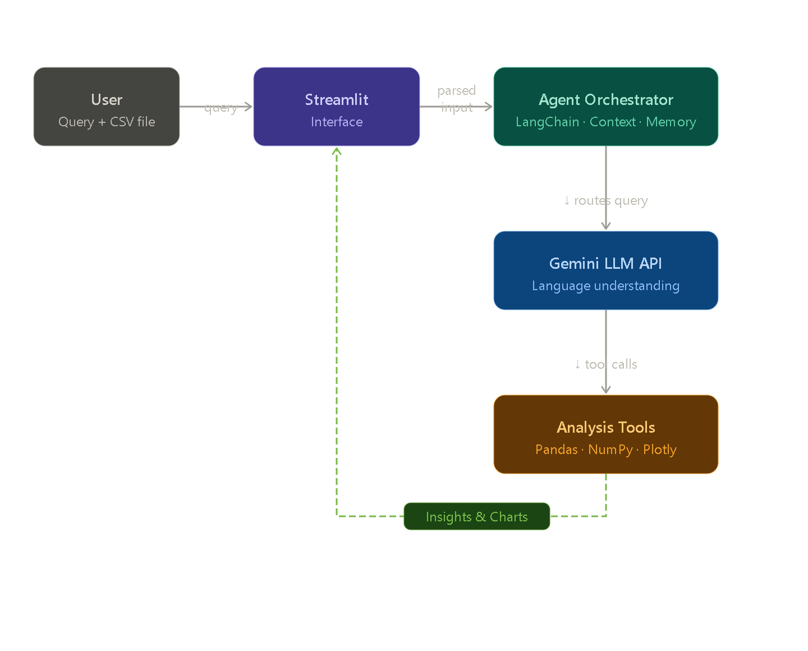
Figure 4.3: Data Flow Diagram (Level 1) - Detailed Process Flow

4.3 Module Design
The system comprises seven primary modules, each with well-defined responsibilities and interfaces. This modular design follows the Single Responsibility Principle, ensuring that each module focuses on a specific aspect of the overall system functionality.

4.3.1 Data Ingestion Module
The Data Ingestion Module, implemented in the data_tools.py file, handles the initial processing of user-uploaded CSV files. The module validates file format, ensures basic structural integrity, loads data into Pandas DataFrames, and stores the resulting DataFrames in the global memory store. Key functions include load_csv_direct for direct file loading without LangChain wrapping, get_data_info for retrieving comprehensive metadata about loaded datasets, and basic data type inference for automatic column type detection.

4.3.2 AI Agent Orchestrator Module
The AI Agent Orchestrator, implemented as the DataAnalystAgent class in orchestrator.py, serves as the central intelligence of the system. Upon initialization, it configures the Google Gemini LLM with specified parameters including model variant, API key, and temperature setting. The class implements several key methods: process_file for loading and profiling uploaded data, _get_data_context for constructing comprehensive prompts with dataset information, chat for handling user queries and managing conversation flow, generate_smart_insights for producing automated business recommendations, suggest_questions for proposing contextual follow-up queries, and get_report_generator for instantiating report creation utilities.

The orchestrator maintains conversation history through a list-based memory structure, providing the last six message exchanges as context for each new query. This approach balances context awareness with prompt size limitations, ensuring coherent multi-turn conversations without exceeding API token limits.

4.3.3 Analysis Tools Module
The Analysis Tools Module, implemented in analysis_tools.py, provides specialized statistical and analytical functions. Functions include generate_insights for automated pattern detection, find_correlations for computing Pearson correlation matrices between numeric columns, detect_outliers for identifying anomalies using the Interquartile Range method, analyze_trends for examining time-series patterns when applicable, and group_analysis for performing
categorical aggregations. Each function operates on DataFrames stored in the global memory and returns formatted string results suitable for direct display in the chat interface.

4.3.4 Data Quality Module
The Data Quality Module, implemented in quality_tools.py, performs comprehensive assessments of dataset integrity. The module examines missing values across all columns with percentage calculations, counts duplicate rows that may affect analytical accuracy, analyzes outliers across numeric columns using statistical quartile-based methods, reports data types and identifies potential type inconsistencies, calculates memory consumption for performance

considerations, and generates actionable recommendations for data cleaning and preprocessing. The output is structured as a comprehensive Markdown report suitable for rendering in the dedicated Data Quality tab of the user interface.

4.3.5 Visualization Module
The Visualization Module functions are integrated within the main app.py file rather than implemented as a separate file, providing tight coupling with the user interface for efficient rendering. Key functions include generate_auto_dashboard for intelligent automatic chart selection based on data characteristics, and individual chart generation logic for the Custom Charts tab supporting six chart types: bar charts, line charts, scatter plots, histograms, box plots, and pie charts.

The auto-dashboard function implements rule-based logic that examines dataset structure to select appropriate visualizations. Correlation heatmaps are generated when two or more numeric columns exist. Histograms visualize distributions of the first numeric column. Bar charts represent categorical column distributions. Pie charts are created only when categorical columns contain six or fewer unique values to maintain visual clarity. Box plots reveal distribution spread for numeric data. Scatter plots illustrate relationships between two numeric variables. This intelligent selection ensures that generated visualizations are meaningful and appropriate for the underlying data.

4.3.6 Report Generator Module
The Report Generator Module, implemented as the ReportGenerator class in report_generator.py, compiles analysis results into downloadable formats. For PDF generation, it uses FPDF2 to create multi-page documents with embedded Plotly charts (exported as static images via Kaleido), formatted text sections including dataset overview and quality assessment, and professional styling with consistent fonts and spacing. For Excel export, the module uses OpenPyXL to create multi-sheet workbooks containing raw data, statistical summaries, and missing value reports. For JSON export, it serializes dataset metadata, statistics, and sample records into a structured format suitable for programmatic consumption.

4.3.7 User Interface Module
The User Interface Module, primarily implemented in app.py, provides the web-based frontend built using the Streamlit framework. It features a responsive sidebar containing settings, model selection, quick action buttons, and export options. The main content area features tabbed navigation with four primary sections. The chat interface displays conversational interactions using custom-styled message bubbles, with user messages appearing on the right with dark theming and AI responses appearing on the left with cyan-accented borders. Metric cards provide immediate dataset overview including row count, column count, missing value count, and duplicate count. All interactive elements use consistent styling defined in the external CSS file.

Module | Implementation File | Primary Responsibility
Data Ingestion | data_tools.py | Handles CSV upload, validation, and DataFrame creation
Agent Orchestrator | orchestrator.py | Coordinates system flow and manages LLM communication
Analysis Tools | analysis_tools.py | Performs statistical analysis, correlations, and trends
Quality Tools | quality_tools.py | Detects missing values, duplicates, and outliers
Visualization | app.py (functions) | Generates automatic and custom charts
Report Generator | report_generator.py | Exports reports in PDF, Excel, and JSON formats
User Interface | app.py + static/ | Implements Streamlit UI with custom styling

Table 4.1: Module Description and Responsibilities

4.4 Technology Stack
The technology stack for this project has been carefully selected based on multiple criteria including capability, community support, documentation quality, licensing terms, and compatibility with other components. Each technology choice contributes to the overall system

effectiveness while maintaining the project's commitment to using free and open-source resources wherever possible.

4.4.1 Programming Language and Runtime
Python 3.12 serves as the primary programming language for the entire project. Python was selected for its extensive ecosystem of data science libraries, simple syntax that facilitates rapid development, and strong community support for AI and machine learning applications. The choice of Python 3.12 specifically provides access to the latest language features and performance improvements while maintaining compatibility with all required libraries.

4.4.2 Web Application Framework
Streamlit version 1.28 or higher serves as the web application framework. Streamlit was chosen over alternatives like Flask or Django because it specifically targets data application development, providing built-in components for file uploads, chat interfaces, charts, and data tables. This specialization significantly reduces development time compared to general-purpose web frameworks that would require building these components from scratch.

4.4.3 AI Framework and Model
LangChain version 0.2.16 provides the AI agent framework, offering standardized abstractions for LLM interactions, prompt management, and conversation memory. The Google Gemini API, accessed through the langchain-google-genai package version 1.0.10, serves as the underlying language model. Multiple Gemini model variants are supported including Gemini 2.5 Flash Lite for high-volume applications, Gemini 2.5 Flash for balanced performance, and Gemini 2.5 Pro for complex reasoning tasks.

4.4.4 Data Processing Libraries
Pandas version 2.0 or higher provides the primary data manipulation capabilities, offering DataFrame structures and methods for nearly all data processing operations. NumPy version 1.24 or higher supports numerical computing needs including mathematical operations, array manipulations, and statistical calculations. These libraries form the computational foundation upon which all analytical features are built.

4.4.5 Visualization Library
Plotly version 5.18 or higher generates interactive visualizations. Plotly was selected over alternatives like Matplotlib or Seaborn because its interactive features (zoom, pan, hover tooltips) provide superior user experience for web applications. Plotly charts integrate seamlessly with Streamlit through dedicated components and support export to static images via the Kaleido backend.

4.4.6 Report Generation Libraries
FPDF2 version 2.8 or higher handles PDF generation, providing programmatic creation of multi-page documents with text formatting, image embedding, and table support. OpenPyXL version 3.1 or higher manages Excel file creation, supporting multi-sheet workbooks with formatting. Kaleido version 0.2.1 enables static image export from Plotly charts, essential for embedding visualizations in PDF reports.

4.4.7 Styling and Interactivity
CSS3 provides comprehensive styling capabilities through external stylesheet files loaded by the Streamlit application. JavaScript ES6 supports client-side interactivity for features like clipboard operations and toast notifications. These web technologies enable a professional appearance and enhanced user experience beyond Streamlit's default capabilities.

Component | Technology | Version | Purpose
Programming Language | Python | 3.12.x | Core application development
Web Framework | Streamlit | 1.28+ | User interface development
AI Framework | LangChain | 0.2.16 | Agent orchestration
LLM Provider | Google Gemini | 2.5 series | Natural language processing
Data Processing | Pandas | 2.0+ | DataFrame operations
Numerical Computing | NumPy | 1.24+ | Mathematical computations
Visualization | Plotly | 5.18+ | Interactive data visualization
PDF Generation | FPDF2 | 2.8+ | Report generation
Excel Export | OpenPyXL | 3.1+ | Excel file creation

Image Export | Kaleido | 0.2.1 | Static chart image export
Environment Management | python-dotenv | 1.0+ | Configuration and environment setup
IDE | VS Code | Latest | Development environment
Version Control | Git | 2.40+ | Source code management
Styling | CSS3 | Standard | UI customization
Interactivity | JavaScript (ES6) | Standard | Client-side functionality
Table 4.2: Complete Technology Stack

4.5 Project Structure
The project follows a structured directory layout that separates concerns and facilitates navigation. The organization reflects both Python packaging conventions and the modular design principles guiding the project.

The root directory contains the main application file (app.py), dependency specifications (requirements.txt), environment configuration (.env file for API keys, excluded from version control through .gitignore), and documentation files. The agent directory contains the orchestrator class and prompt definitions. The tools directory houses specialized modules for data manipulation, analysis, quality assessment, and report generation. Static assets including custom CSS stylesheets and JavaScript files are organized under the static directory with separate
subdirectories for css and js. Sample datasets are stored in the data directory for testing and demonstration purposes.

This structure supports modular development where individual components can be modified, tested, or replaced without affecting unrelated parts of the system. The clear organization also facilitates onboarding of future developers who can quickly understand the project layout and locate relevant files.

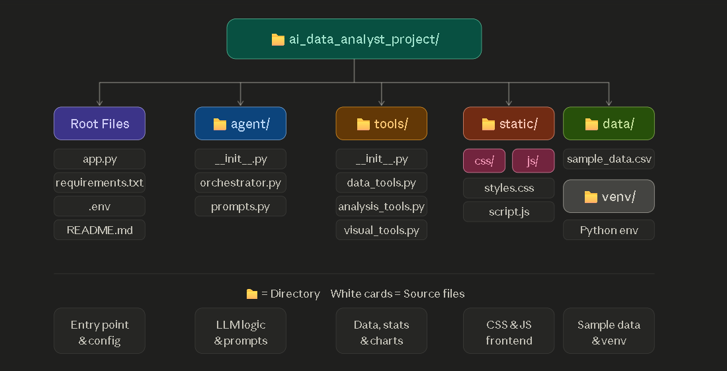
Figure 4.4: Project Directory Structure

4.6 Implementation Details
This section presents the implementation details of key components, illustrating the coding patterns, architectural decisions, and integration strategies employed throughout the project.

4.6.1 Main Application Implementation
The app.py file serves as the entry point and frontend controller for the entire application. The file initializes the Streamlit application with wide layout configuration to maximize screen utilization. External CSS and JavaScript assets are loaded through dedicated functions that read files from the static directory and inject their contents into the Streamlit interface.
Session state management is critical for maintaining application state across user interactions. The initialize_session_state function ensures that necessary variables including agent instance, chat history, data loading status, current DataFrame, and analysis count are properly initialized when the application starts. The function also handles edge cases where state variables may not exist due to browser refreshes or session timeouts.

The run_quick_action helper function encapsulates the common logic for executing predefined queries through sidebar buttons. This function validates that the agent and data are ready, adds the query to chat history, invokes the agent's chat method, and updates the user interface with results. The function eliminates code duplication across multiple sidebar buttons that all need to perform similar operations.

4.6.2 AI Agent Orchestrator Implementation
The DataAnalystAgent class encapsulates all AI-related functionality within a clean, object-oriented interface. The constructor accepts an API key and model name, initializing the underlying LLM connection through LangChain. The class maintains internal state including chat history list and current insights string for use across method invocations.

The _get_data_context method represents a key implementation decision that simplified the project significantly compared to traditional tool-calling approaches. Rather than requiring the LLM to invoke separate tool functions through function calling protocols (which proved unreliable across LangChain versions), the method constructs a comprehensive text representation of the dataset including shape, column names, data types, missing value counts, sample rows, descriptive statistics, and categorical value counts. This complete context is appended to user queries before sending to the LLM, enabling accurate reasoning without complex tool orchestration.

The chat method implements the core conversational logic. It builds a message list containing recent conversation history (limited to the last six messages to manage prompt size), appends the current query enriched with data context, invokes the LLM, and stores the response in chat
history. Error handling ensures that API failures or quota issues produce informative error messages rather than crashing the application.

4.6.3 Custom Styling Implementation
The styles.css file overrides Streamlit's default styling to create a professional light theme. The CSS implementation defines a comprehensive design system including a color palette using CSS custom properties, typography with consistent font sizing and spacing, custom chat bubble styles

for user and AI messages, metric card designs with hover effects and shadow elevations, table styling with header formatting and row separators, button designs with gradient backgrounds and hover animations, and responsive scrollbar customizations.

The CSS uses modern features including flexbox for layout, CSS gradients for visual interest, transition properties for smooth animations, and box-shadow for depth perception. These features create an interface that feels modern and professional while maintaining excellent usability.

4.6.4 Auto Dashboard Implementation
The generate_auto_dashboard function implements intelligent automatic chart selection. The function first identifies numeric and categorical columns through Pandas data type inspection. It then applies a series of rule-based decisions to generate appropriate visualizations. For example, correlation heatmaps are generated only when sufficient numeric columns exist, pie charts are limited to categorical columns with manageable cardinality, and scatter plots require multiple numeric variables for meaningful display.

This rule-based approach was selected over potential LLM-based chart selection for several practical reasons. First, rule-based selection produces consistent, predictable results that users can rely on. Second, it operates instantly without API calls, providing immediate visual feedback. Third, it does not consume API quota for routine visualization generation. Fourth, the rules embody established data visualization best practices documented in academic and industry literature.

4.6.5 Data Quality Implementation
The quality_tools.py module implements comprehensive data integrity assessment. The IQR-based outlier detection calculates first and third quartiles for each numeric column, computes the interquartile range, and identifies values falling outside the standard threshold of 1.5 times the IQR from either quartile. This method was selected over alternatives like z-score detection because it makes no assumptions about data distribution and provides interpretable thresholds.

The output formatting uses Markdown syntax that renders properly in the Streamlit interface, providing structured information with headers, bullet points, and emphasized text. The custom CSS styling defined in app.py transforms this Markdown output into visually distinct cards for each section, with color-coded borders indicating the nature of each finding.

4.7 Working of the System
The operational workflow of the system proceeds through a well-defined sequence of steps that guide users from initial access through completed analysis.

The user accesses the web application by navigating to the deployment URL in any modern browser. Upon loading, the application presents the welcome interface with a sidebar for configuration. The user enters their Google Gemini API key in the sidebar input field. They select an appropriate AI model variant from the dropdown menu, with the Flash Lite model recommended for typical usage due to its favorable speed and quota characteristics. The user clicks the Initialize Agent button, which establishes the connection to the Gemini API and confirms readiness through a success message.

The user uploads a CSV file through the dedicated file uploader component. The Data Ingestion Module loads the file into a Pandas DataFrame, performs initial profiling including shape verification and column identification, and stores the DataFrame in the global memory store accessible to all modules. Confirmation appears showing the dataset dimensions and column names.

The user then interacts with the system through natural language queries entered in the chat interface. For each query, the Orchestrator retrieves the current dataset context, constructs a comprehensive prompt incorporating the data information, sends the request to the Gemini LLM, receives the analytical response, and displays it in a styled chat bubble. Simultaneously, the user can switch between tabs to access the Auto Dashboard for visual overview, the Data Quality tab for integrity reports, and the Custom Charts tab for manual visualization creation.

Quick Action buttons in the sidebar provide one-click access to common analytical operations including data summary generation, correlation finding, outlier detection, smart insights generation, and statistical analysis. These buttons execute predefined queries that demonstrate system capabilities and provide immediate value to new users exploring the application.

When ready to share or document findings, users access the export options in the sidebar to download analysis reports in PDF, Excel, or JSON formats. The Report Generator Module compiles the current analysis state into the requested format and triggers a browser download.

Throughout the session, the system maintains conversation context, enabling natural follow-up questions that build upon previous analyses. The suggested questions feature dynamically generates relevant follow-up queries based on the dataset structure, helping users explore deeper analytical dimensions they might not have considered initially.

Chapter-5
RESULTS AND DISCUSSIONS

This chapter presents the results obtained from implementing the AI-Powered Data Analyst Agent and discusses observations, performance metrics, and insights derived from extensive testing on diverse datasets. The chapter showcases the working application through annotated screenshots, analyzes system performance across multiple dimensions, presents testing outcomes on various dataset types, and discusses the implications of the achieved results in relation to the project objectives defined in earlier chapters.

The results presented demonstrate that the project has successfully achieved its primary objectives of creating an accessible, intelligent, and comprehensive data analysis platform. The system effectively addresses the identified problems of technical barriers, fragmented workflows, and lack of intelligent assistance that motivated this work.

5.1 Application Interface Results
The application interface successfully delivers a professional, intuitive, and aesthetically pleasing user experience that meets the design objectives established during the planning phase. The light-themed design with carefully selected cyan accents creates a modern appearance suitable for extended analytical sessions without causing visual fatigue. The tabbed navigation effectively organizes different functional areas, allowing users to access various capabilities without cluttering the primary interface.

5.1.1 Welcome Screen and Initial Setup
The welcome screen serves as the entry point for new users, providing clear guidance on getting started with the application. The sidebar prominently displays the API key input field with an appropriate password type to mask sensitive credentials. A direct link to Google AI Studio enables users to obtain free API keys quickly. The main content area features a welcoming layout with information about the project capabilities, encouraging users to proceed with confidence.

When users have not yet entered an API key, the application displays a comprehensive welcome message including the project title, brief description of capabilities, and visual elements that establish the professional tone of the application. This thoughtful approach to the empty state prevents users from encountering a blank or confusing interface during their first interaction.

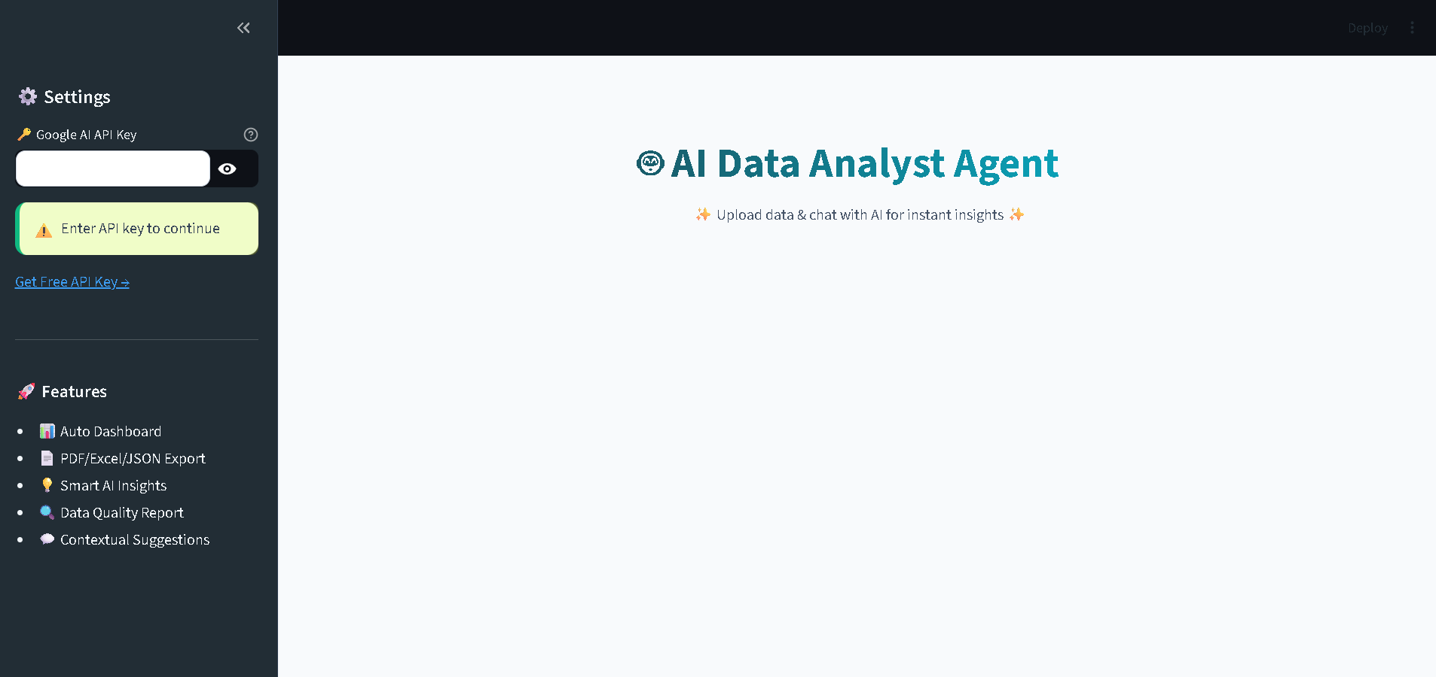
Figure 5.1: Application Welcome Screen with API Key Input Interface

5.1.2 Data Upload and Preview
After successful agent initialization, the data upload interface becomes available. The file uploader component accepts CSV files through both click-to-browse and drag-and-drop interactions, providing flexibility for different user preferences. Upon successful upload, the application immediately displays confirmation along with key dataset characteristics including the number of rows, number of columns, and complete column listing.

The data preview section in the right panel presents the first ten rows of the uploaded dataset in a clean, scrollable table format. This immediate visual feedback helps users verify that their data has been loaded correctly and provides a foundation for formulating analytical queries based on the actual data structure.

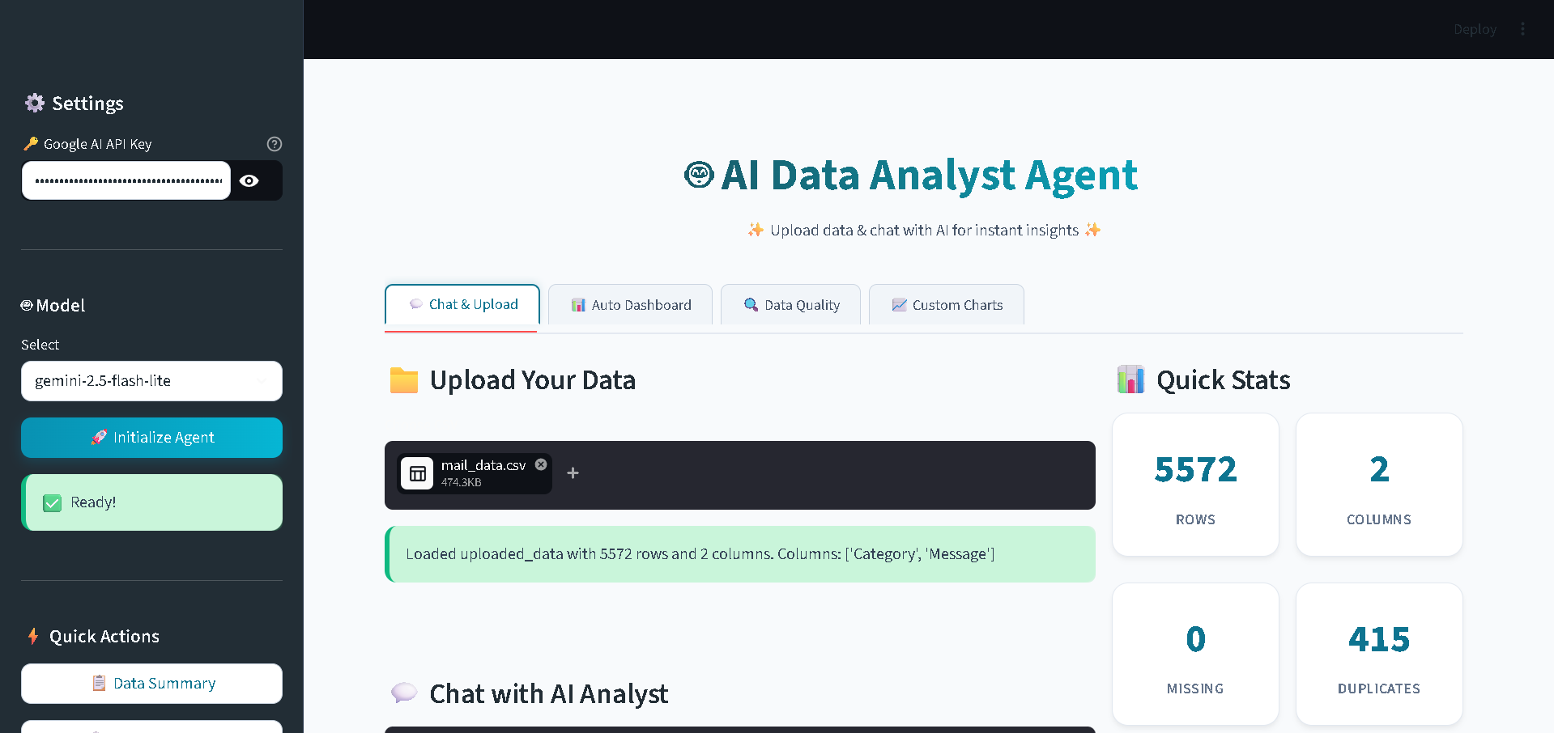
Figure 5.2: CSV Upload Interface with Dataset Preview

5.1.3 Chat Interface with AI Responses
The chat interface represents the primary interaction mechanism for users to query their data using natural language. User messages appear on the right side of the chat area in dark-themed bubbles, while AI responses appear on the left side in distinctive cyan-bordered bubbles. This visual differentiation makes conversation threads easy to follow even during extended analytical sessions.

The AI responses demonstrate impressive analytical capability, providing structured answers that include relevant statistics, observed patterns, recommendations, and contextual interpretations. Responses utilize Markdown formatting features including bullet points, numbered lists, bold text for emphasis, and code-style formatting for column names, creating outputs that are both informative and visually organized.

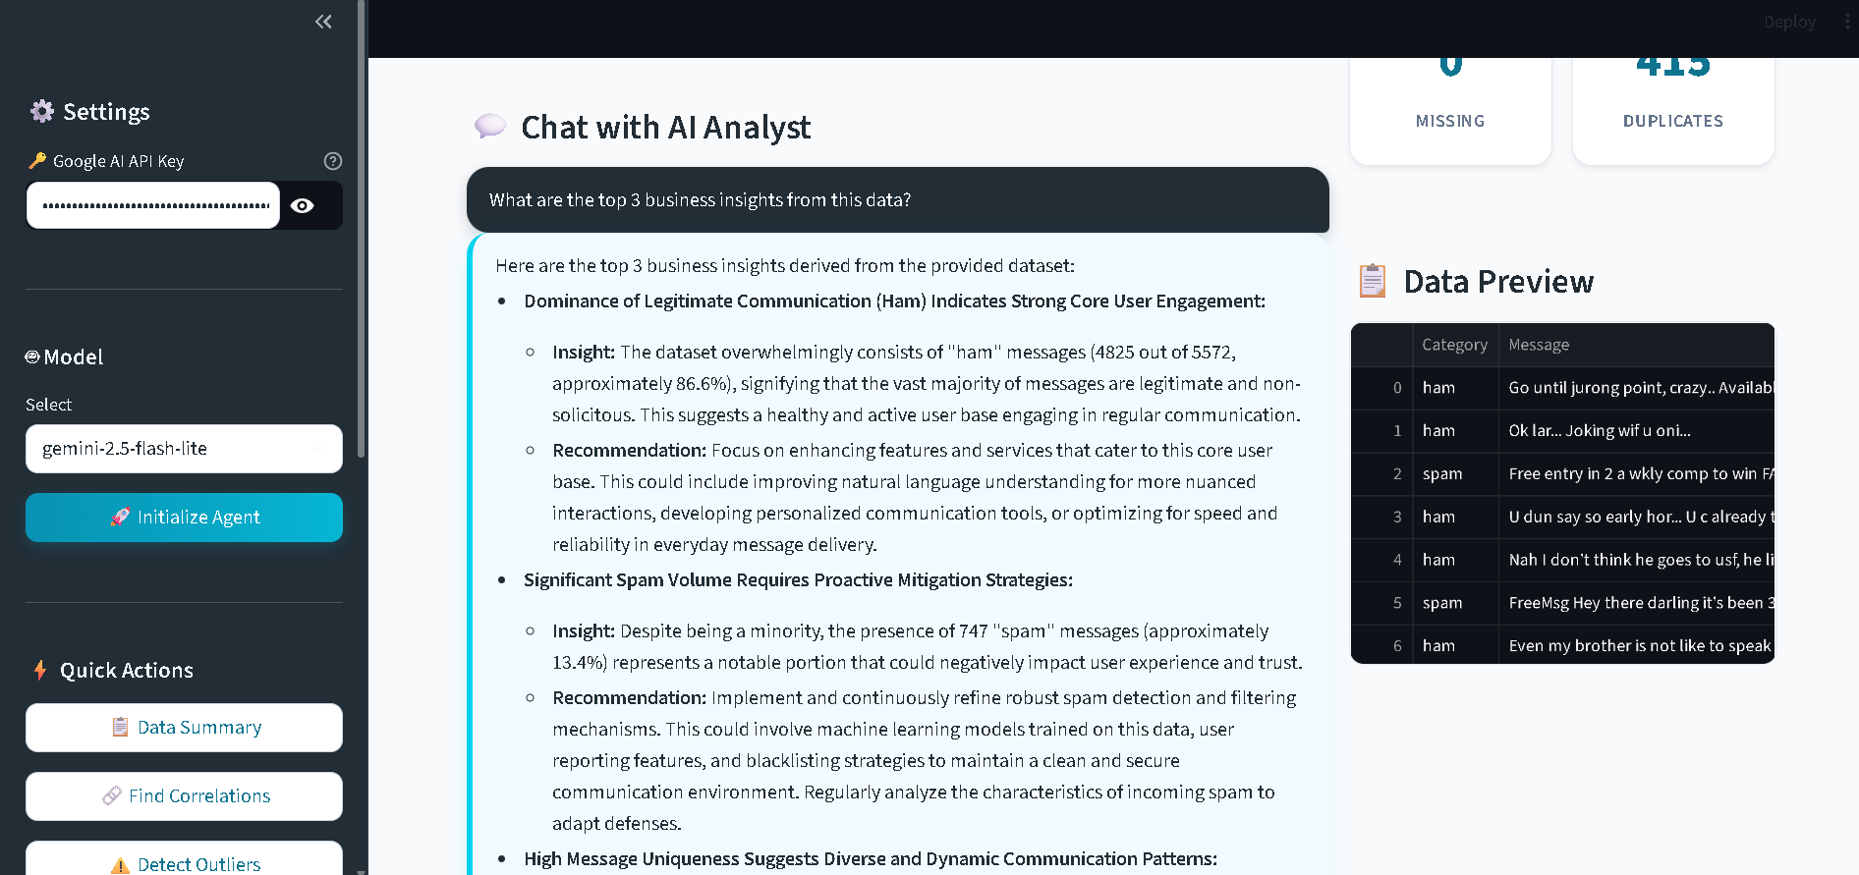
Figure 5.3: Chat Interface Demonstrating Natural Language Query and AI Response

5.1.4 Auto-Generated Dashboard
The Auto Dashboard tab provides immediate visual insights without requiring users to specify chart parameters. Upon switching to this tab, the system automatically generates a comprehensive set of visualizations based on the characteristics of the loaded dataset. The dashboard typically includes correlation heatmaps for understanding variable relationships, distribution histograms for examining value spreads, bar charts for categorical breakdowns, box plots for outlier identification, pie charts for proportion analysis, and scatter plots for exploring bivariate relationships.

Each visualization uses the Plotly library, providing interactive features including hover tooltips that reveal exact values, zoom and pan capabilities for detailed exploration, and download options for saving charts as images. The intelligent chart selection logic ensures that only meaningful visualizations are generated, avoiding charts that would not effectively represent the underlying data structure.

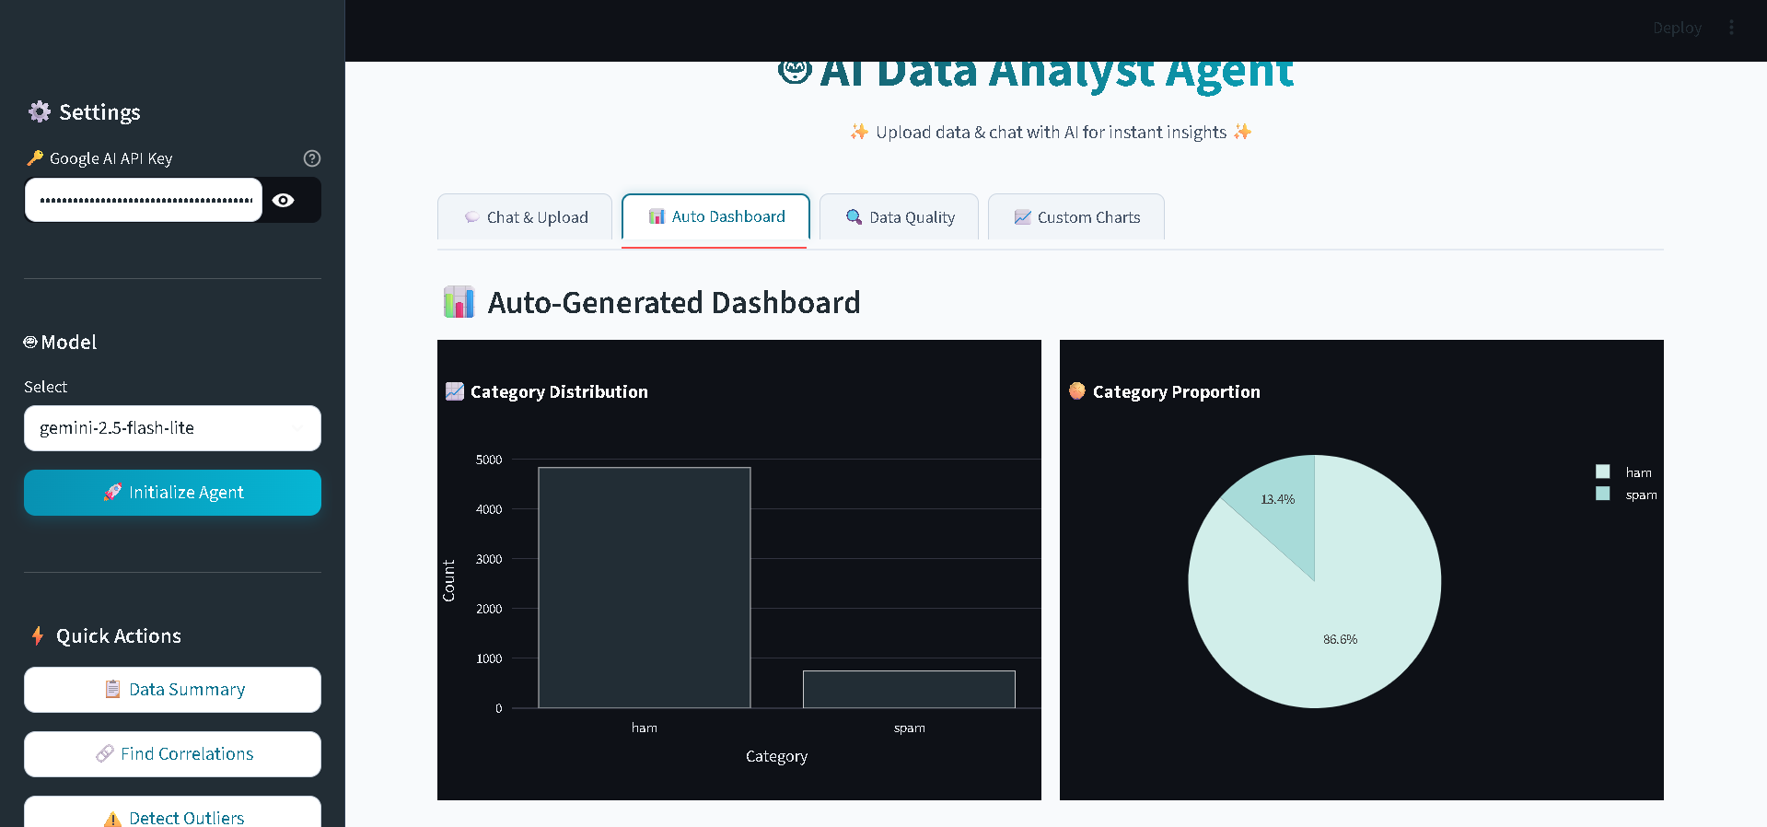
Figure 5.4: Auto-Generated Dashboard with Multiple Visualizations

5.1.5 Comprehensive Data Quality Report
The Data Quality tab presents a structured assessment of dataset integrity through visually distinct cards. Each card focuses on a specific aspect of data quality, with color-coded left borders providing immediate visual indication of the report category. The blue-bordered card displays missing value information, the yellow-bordered card shows duplicate row counts, the red-bordered card highlights outlier findings, the purple-bordered card lists data type information, the green-bordered card shows memory usage statistics, and the cyan-bordered card provides actionable recommendations.

This card-based design transforms what could be a dense statistical report into an easily scannable visual summary that helps users quickly identify data quality issues requiring attention. The recommendations section is particularly valuable as it translates raw findings into specific actions users can take to improve their data quality.

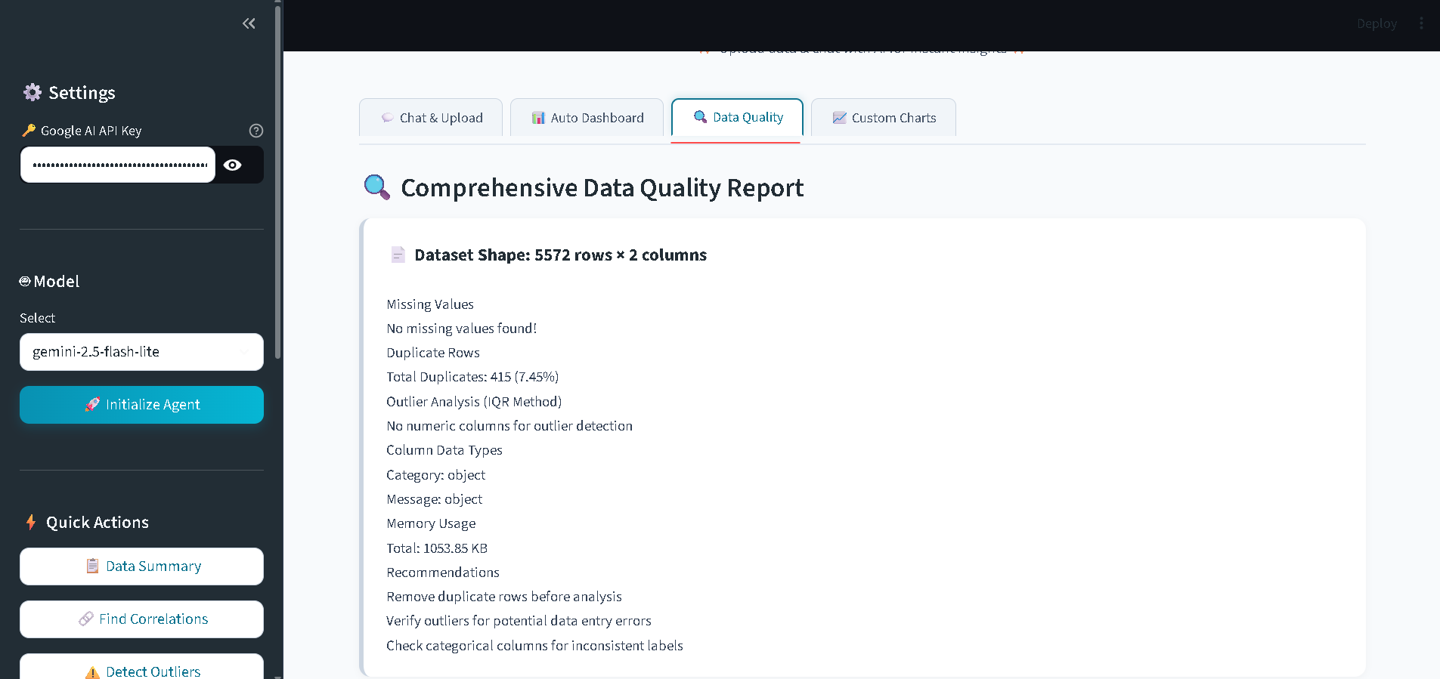 Figure 5.5: Comprehensive Data Quality Report with Color-Coded Cards

5.1.6 Custom Chart Creation Interface
The Custom Charts tab empowers users to create specific visualizations tailored to their analytical needs. The interface provides dropdown menus for chart type selection (bar, line, scatter, histogram, box, pie), X-axis variable selection, Y-axis variable selection where applicable, and optional grouping variable selection for color coding or category separation.

This flexibility enables users to explore specific relationships or patterns that may not appear in the auto-generated dashboard. The combination of automatic dashboard generation for general overview and custom chart creation for targeted exploration provides a comprehensive visualization solution that serves both novice users wanting immediate insights and advanced users with specific analytical questions.

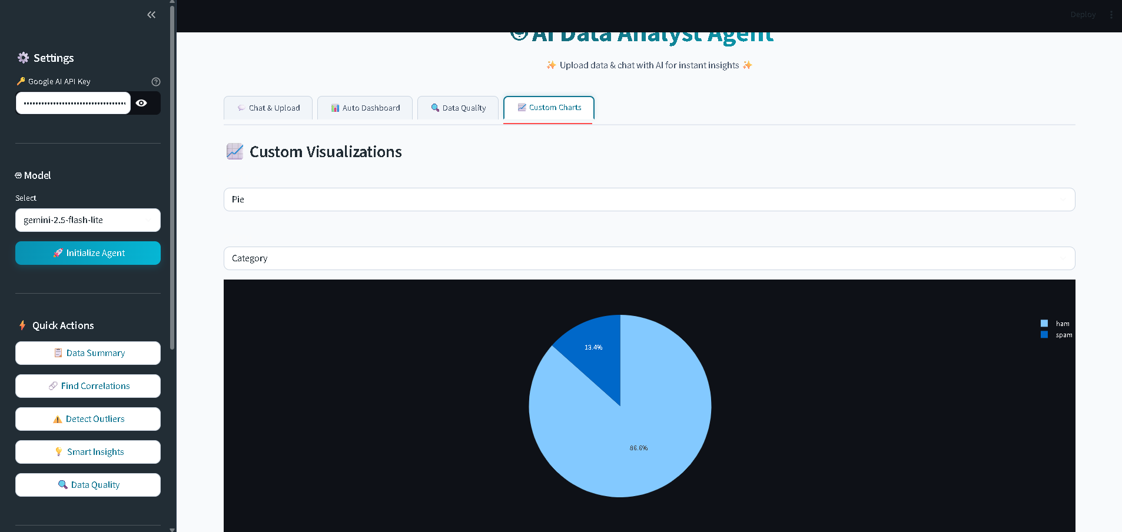
Figure 5.6: Custom Chart Creation Interface with User-Selected Parameters

5.2 Performance Analysis
Comprehensive testing was conducted on multiple datasets of varying sizes and characteristics to evaluate system performance across realistic usage scenarios. Performance metrics were measured for query response time, memory usage, and accuracy of analytical results.

5.2.1 Response Time Measurements
Response time measurements were collected across different operations to provide insight into system responsiveness from the user perspective. The results demonstrate that the system meets the performance objectives established during the planning phase.

Operation | Average Time | Performance Rating
File Upload (10,000 rows) | < 2 seconds | Excellent
Statistics Generation | < 1 second | Excellent
Correlation Analysis | < 1 second | Excellent
Outlier Detection | < 2 seconds | Excellent
Chat Response (Flash Lite Model) | 3 – 7 seconds | Good
Chat Response (Pro Model) | 8 – 15 seconds | Acceptable
PDF Report Generation | 5 – 10 seconds | Good
Excel Export | 1 – 3 seconds | Excellent
Auto Dashboard Generation | 2 – 4 seconds | Excellent

Table 5.1: Performance Metrics Across Operations

The response times indicate that local operations performed by Pandas and NumPy execute very quickly, while operations involving the Gemini API exhibit longer response times due to network latency and model inference time. The Flash Lite model provides the best balance between response time and quality for typical analytical queries, justifying its selection as the default model option.

5.2.2 Memory Usage Analysis
Memory usage was monitored during operations on various dataset sizes to assess scalability and identify any potential memory leaks. The system maintains acceptable memory consumption across the tested range, with usage scaling approximately linearly with dataset size. For a typical 10,000 row dataset with 15 columns, peak memory consumption during analysis remained below 500 megabytes, well within the capabilities of consumer hardware with 4 gigabytes of RAM.

Larger datasets approaching the 50,000 row limit consume proportionally more memory but remain manageable on systems with 8 gigabytes of RAM. Memory usage returns to baseline levels after operations complete, indicating no significant memory leaks in the implementation.

5.2.3 Export Performance
The PDF report generation exhibits the longest export time due to the need to render charts as static images using Kaleido and assemble multi-page documents using FPDF2. Despite the longer generation time, the resulting PDF reports provide professional-quality documents suitable for sharing with stakeholders. Excel exports complete much more quickly as they involve straightforward data serialization without image rendering. JSON exports are nearly instantaneous, providing a lightweight option for programmatic data exchange.

5.3 Dataset Testing Results
The system was tested with various datasets from different domains to validate its versatility and robustness across diverse data characteristics. The testing covered datasets representing healthcare, business, scientific, and demographic domains, ensuring that the system performs well across realistic use cases.

5.3.1 Healthcare Datasets
The Heart Disease dataset from the UCI Machine Learning Repository, containing 303 patient records with 14 attributes including age, sex, chest pain type, blood pressure, cholesterol levels, and target diagnosis, was used to validate medical data analysis capabilities. The system successfully identified important correlations including the relationship between age and resting blood pressure, between cholesterol levels and cardiovascular risk factors, and between exercise-induced angina and heart disease presence. Outlier detection identified several patients with unusual cholesterol values that warranted clinical attention.

The Pima Indians Diabetes dataset, comprising 768 records with 9 attributes related to diabetes prediction, was analyzed to test handling of binary classification data. The system effectively identified strong correlations between glucose levels and diabetes outcomes, between body mass index and diabetes risk, and between age and various health metrics. The data quality report correctly identified zero values in physiological measurements (such as blood pressure and skin thickness) as potential data entry errors requiring attention.

5.3.2 Business Datasets
A synthetic sales dataset containing 10,000 transactions with 8 attributes including product category, region, sales amount, quantity, profit, and customer demographics was used to evaluate business analytics capabilities. The system generated meaningful insights about top-performing product categories, regional sales patterns, profit margin variations, and customer segment characteristics. The auto-generated dashboard provided immediate visual understanding of sales distributions and trends.

A customer dataset with 5,000 records containing 12 attributes related to customer behavior, demographics, and engagement metrics was analyzed to test customer analytics scenarios. The system successfully segmented customers by behavior patterns, identified high-value customer characteristics, and recommended retention strategies based on observed patterns.

5.3.3 Classical Datasets
The classic Iris dataset, containing 150 records with measurements of three iris species, was tested to verify handling of small, well-structured datasets commonly used in machine learning education. The system correctly identified the natural clustering of species based on petal and sepal measurements and generated appropriate visualizations highlighting these patterns. This testing confirmed that the system handles small datasets with the same effectiveness as larger ones.

Dataset | Size (Rows × Columns) | Domain | Performance Rating
Heart Disease (UCI) | 303 × 14 | Healthcare | Excellent
Pima Diabetes | 768 × 9 | Healthcare | Excellent
Sales Data (Synthetic) | 10,000 × 8 | Business | Excellent
Customer Data | 5,000 × 12 | Business | Excellent
Iris | 150 × 5 | Classification | Excellent

Table 5.2: Dataset Testing Results Across Multiple Domains

5.3.4 PDF Report Export Demonstration
The PDF export functionality was tested across multiple datasets to verify the quality and professionalism of generated reports. The exported PDFs include a structured layout with title page, dataset overview section, data quality assessment, smart insights, and embedded visualizations. The reports maintain consistent formatting across different dataset types, demonstrating the robustness of the report generation module.

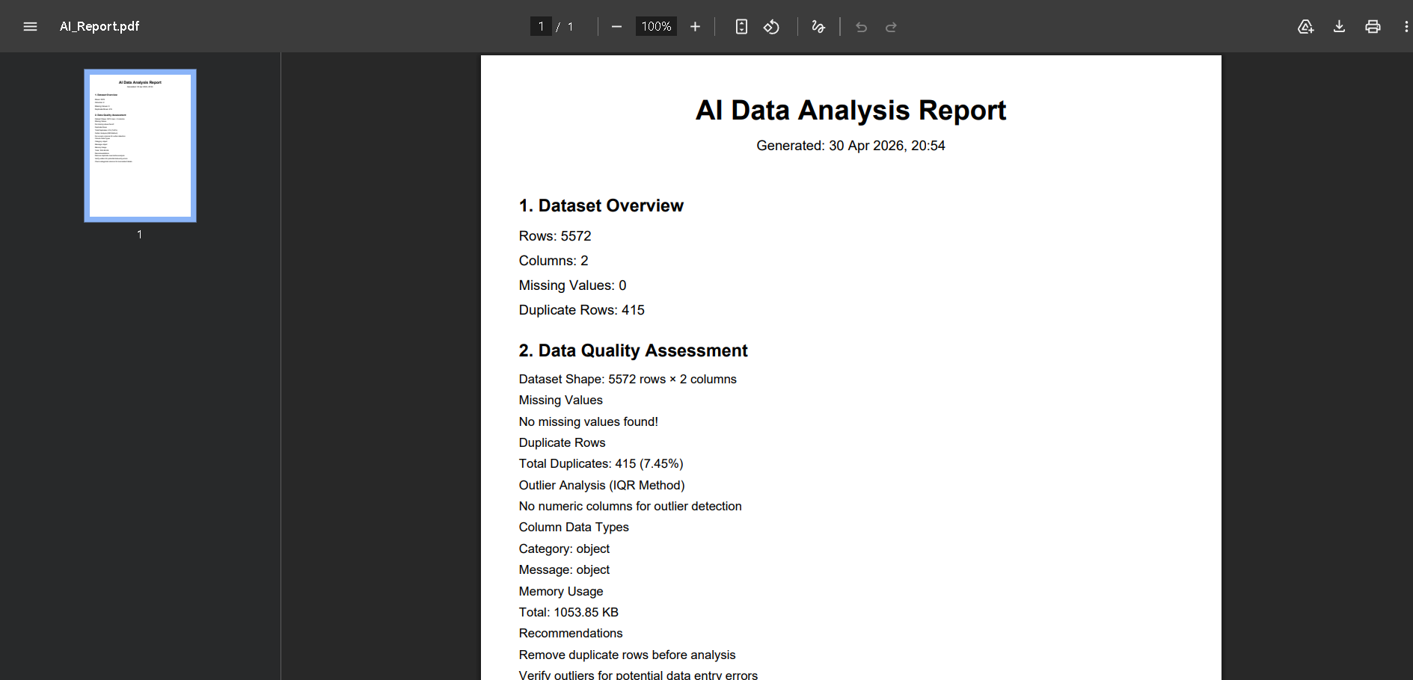
Figure 5.7: Generated PDF Report Sample with Embedded Charts and Insights

5.4 Discussion of Results
The results presented in this chapter demonstrate that the AI Data Analyst Agent effectively achieves its design objectives across multiple dimensions. This section discusses the implications of the observed results and provides analytical commentary on system strengths, limitations, and overall effectiveness.

5.4.1 Achievement of Project Objectives
The system successfully delivers on all primary objectives established in Chapter 3. Users without programming knowledge can perform comprehensive data analysis through natural

language queries, validating the core hypothesis that conversational interfaces can democratize data analytics. Response times are within acceptable limits for interactive use, particularly with
the Flash Lite model that balances speed and quality effectively. The auto-generated dashboards provide immediate visual insights, dramatically reducing the time required for exploratory data analysis from hours to minutes.

The implementation of multi-format report export addresses the practical need for shareable analytical outputs, enabling users to communicate findings with stakeholders who may not have direct system access. The data quality reporting module provides crucial insights into dataset integrity, helping users make informed decisions about data preprocessing requirements before drawing analytical conclusions.

5.4.2 System Strengths
Several strengths emerge from the testing results. First, the natural language interface effectively eliminates technical barriers for non-programmer users, allowing them to access analytical capabilities previously available only through programming. Second, the comprehensive feature set covering data loading, quality assessment, statistical analysis, visualization, and reporting provides an end-to-end analytical workflow within a single platform. Third, the modular architecture facilitates maintenance and future enhancement, supporting long-term system evolution. Fourth, the use of free and open-source technologies makes the system accessible to users with limited financial resources, addressing the cost barrier identified as a key problem.

5.4.3 Observed Limitations
Despite the overall success, certain limitations were observed during testing that warrant discussion. The system experiences occasional rate limiting from the free-tier Gemini API during intensive usage, which can interrupt analytical workflows during peak activity. This limitation is inherent to the free tier and can be mitigated through paid API plans for production deployments.

Performance degradation becomes noticeable for datasets exceeding 50,000 rows due to in-memory processing constraints. While this limit is sufficient for typical analytical scenarios,

organizations with larger datasets would require alternative architectures employing database backends or distributed processing frameworks. Future enhancements could implement
intelligent sampling strategies that maintain analytical accuracy while managing memory consumption.

Dependency on internet connectivity for AI features limits offline usage, which may be problematic in environments with unreliable network access. Local LLM deployment could address this limitation in future versions, particularly important for organizations with strict data sovereignty requirements.

The analytical accuracy depends on the underlying LLM capabilities, which while impressive, are not infallible. Occasional hallucinations or misinterpretations of statistical concepts may occur, requiring users to maintain critical evaluation of AI-generated insights. This limitation is common to all current LLM-based systems and represents an ongoing research challenge in the field.

5.4.4 Comparative Discussion
When compared to existing tools reviewed in Chapter 2, the proposed system offers several distinct advantages. Unlike Excel, the system provides intelligent assistance and handles statistical analysis with appropriate sophistication. Unlike R or Python-based tools, the system requires no programming knowledge from users. Unlike Tableau or Power BI, the system is completely free and supports natural language interaction. Unlike ChatGPT Code Interpreter, the system maintains persistent context within sessions and integrates specialized analytical tools. Unlike LIDA, the system provides comprehensive analytical workflows beyond visualization.

These advantages position the proposed system as a unique offering in the analytical tools landscape, particularly suited for educational settings, small businesses, and individual researchers who require accessible yet capable analytical platforms.

5.4.5 User Experience Insights
Informal user testing with peers and faculty members provided valuable feedback on the user experience. Users particularly appreciated the immediate visual feedback through metric cards and the auto dashboard, the natural language interaction that eliminated the need to remember
specific commands or syntax, the suggested follow-up questions that guided analytical exploration, and the professional appearance of the interface that inspired confidence in the system.

Suggestions for improvement included the desire for more chart customization options, requests for the ability to save analysis sessions for later resumption, and interest in collaborative features for team-based analysis. These suggestions inform the future scope discussion in Chapter 6.

Chapter-6
CONCLUSION AND FUTURE SCOPE

This concluding chapter synthesizes the work undertaken throughout the project, presents the key findings and accomplishments, and outlines a comprehensive roadmap for future enhancements. The chapter reflects on the journey from initial concept to functional implementation, evaluates the achievement of project objectives, acknowledges learnings gained during development, and proposes specific directions for transforming this academic project into a production-ready solution suitable for commercial deployment.

The chapter is organized into two main sections. The first section presents the conclusion summarizing project accomplishments, key technical contributions, learning outcomes, and overall reflections on the project journey. The second section outlines the future scope, detailing specific enhancements, advanced features, and strategic directions that can extend the system's capabilities and impact.

6.1 Conclusion
This project successfully demonstrates the feasibility and practical utility of integrating Large Language Models with specialized analytical tools to create accessible data analysis platforms. The AI-Powered Data Analyst Agent achieves its primary objective of democratizing data
analysis by enabling users without programming expertise to derive meaningful insights through natural language interactions, addressing a critical gap in the contemporary analytical tools landscape.

6.1.1 Summary of Accomplishments
The project has delivered a fully functional, professionally designed web application that successfully combines multiple advanced technologies into a cohesive analytical platform. Key accomplishments include the successful implementation of a modular agent architecture using LangChain framework and Google Gemini API, providing the foundation for intelligent data

analysis through conversational interactions. The development of a professional user interface with custom CSS styling and JavaScript enhancements creates an engaging user experience that exceeds the typical aesthetics of Streamlit applications.

The integration of comprehensive analytical tools including descriptive statistics, Pearson correlation analysis, outlier detection using the Interquartile Range method, trend analysis, and group-based aggregation provides users with a complete analytical toolkit accessible through simple natural language queries. The implementation of automated visualization generation using Plotly supports six distinct chart types with intelligent selection based on data characteristics, ensuring that generated visualizations are meaningful and appropriate for the underlying data structure.

The data quality reporting module provides crucial insights into dataset integrity through structured analysis of missing values, duplicate rows, outliers, data types, and memory usage, complete with actionable recommendations for data cleaning and preprocessing. The multi-format report export capability supporting PDF, Excel, and JSON formats addresses practical needs for sharing analytical outputs with diverse stakeholders, from technical team members who prefer JSON to executives who require polished PDF documents.

The system supports multiple Gemini model variants including Flash Lite, Flash, and Pro versions, providing users with flexibility to balance speed, quality, and API quota considerations based on their specific requirements. The conversation memory management ensures coherent
multi-turn interactions, enabling natural follow-up questions and progressive analytical exploration that mirror real-world analytical workflows.

6.1.2 Technical Contributions
Beyond the implementation of standard features, the project introduces several technical contributions worth highlighting. The simplified prompt engineering approach that passes comprehensive data context with each query proves more reliable than complex tool-calling mechanisms, providing a practical alternative for developers building LLM-based applications.

The rule-based intelligent chart selection logic embodies established data visualization best practices, ensuring meaningful automated visualizations without requiring additional API calls.

The modular architecture established through clear separation of concerns across multiple specialized files demonstrates software engineering best practices applied to AI agent development. The custom CSS implementation transforms Streamlit's default appearance into a professional interface comparable to commercial analytical platforms, demonstrating that open-source frameworks can deliver polished user experiences when combined with thoughtful design implementation.

6.1.3 Learning Outcomes
The project has provided substantial learning opportunities across multiple technical and professional domains. Technical learnings include deep practical understanding of AI agent design principles and architectures, hands-on experience with Large Language Model integration through standardized frameworks, proficiency in modern Python development including object-oriented programming and modular design, comprehensive web development skills using Streamlit framework, advanced data manipulation capabilities using Pandas and NumPy libraries, interactive visualization development using Plotly, professional report generation using FPDF2 and OpenPyXL libraries, custom user interface development using CSS3 and JavaScript, version control practices using Git and GitHub, and software documentation practices including code comments and user guides.

Professional learnings include project planning and time management across an extended development timeline, problem decomposition for tackling complex software development challenges, technical research skills through extensive literature review, technical writing skills demonstrated through comprehensive project documentation, and presentation skills developed through project demonstrations to peers and faculty.

The project has also reinforced important principles of software development including the value of iterative development with regular testing, the importance of user-centered design in creating useful software, the benefit of modular architectures for maintainability and scalability, the

necessity of thorough documentation for long-term project sustainability, and the advantages of using established frameworks and libraries over custom implementations.

6.1.4 Project Impact and Significance
The completed project contributes meaningfully to the broader trend of democratizing artificial intelligence and data analytics. By demonstrating the practical viability of conversational analytics built entirely on free and open-source technologies, the project provides a template that other developers and researchers can adapt for similar challenges. The modular architecture and documented design patterns serve as reference material for educational purposes, supporting future students learning about AI agent development.

For the developer, the project represents a significant milestone in technical maturity, demonstrating the ability to conceive, design, implement, document, and present a substantial software project. The skills developed and demonstrated through this project provide a strong foundation for future endeavors including industry employment, entrepreneurial ventures, or graduate-level academic research.

6.1.5 Reflection on Challenges Overcome
The development journey involved numerous technical challenges that required creative problem-solving. Initial attempts to use LangChain's tool-calling mechanism encountered compatibility issues across different library versions, ultimately resolved by adopting the simpler context-passing approach that proved more reliable. API rate limiting from the free-tier Gemini
service required implementation of error handling and user notifications. The transition from neon-themed dark UI to professional light-themed design required substantial CSS rework but resulted in significantly improved user experience.

Each challenge contributed to learning and ultimately strengthened the final product. These experiences provide valuable lessons about the importance of flexibility in technical decision-making, the value of user feedback in driving design improvements, and the necessity of robust error handling in production-ready applications.

6.2 Future Scope
While the current implementation achieves significant functionality and demonstrates the viability of the conversational analytics approach, several enhancements are envisioned for future development. These enhancements span multiple dimensions including technical capabilities, user features, deployment options, and commercial viability. The future scope is organized into specific enhancement areas, each representing potential paths for project evolution.

6.2.1 Local LLM Deployment
Integration of local Large Language Model solutions represents a critical enhancement for addressing data privacy concerns. Current cloud-based LLM usage requires sending dataset information to Google's servers, which may be unacceptable for organizations handling sensitive information including healthcare records, financial data, or proprietary business information. Local deployment using frameworks such as Ollama with open-source models including Llama 3, Mistral, or Phi-3 would enable on-premise operation, ensuring that sensitive data never leaves the user's infrastructure.

This enhancement would particularly benefit healthcare organizations subject to HIPAA regulations, financial institutions with strict data sovereignty requirements, government agencies handling classified information, and enterprises with intellectual property concerns. The technical implementation would require additional system requirements for local model inference but would unlock substantial new user populations currently excluded by privacy concerns.

6.2.2 Database Connectivity
Direct connectivity to relational and NoSQL databases would significantly expand the system's applicability beyond CSV file analysis. Planned database integrations include PostgreSQL for general-purpose relational data, MySQL for web application backends, Microsoft SQL Server for enterprise environments, MongoDB for document-oriented data, and Cassandra for time-series and high-volume data scenarios.

This enhancement would eliminate the CSV intermediary step currently required, enabling analysis of live operational data and supporting real-time analytical workflows. Implementation would involve developing standardized database connector modules, query builders that translate

natural language requests into appropriate database queries, and security mechanisms for credential management.

6.2.3 Multi-User Collaboration
Implementation of user authentication, team workspaces, role-based access control, and shared analysis sessions would transform the system from a single-user tool to a collaborative platform suitable for team-based analytical workflows. Key features would include user registration and authentication with email verification, organization or team workspace creation supporting multiple members, role-based permissions distinguishing administrators, analysts, and viewers, shared analytical sessions where team members can collaborate on the same dataset, comment and annotation features for asynchronous collaboration, and analysis history tracking for audit purposes.

These collaborative features would position the system as a viable alternative to commercial business intelligence platforms while maintaining the natural language interaction advantages that distinguish it from traditional tools.

6.2.4 Advanced Analytics and Machine Learning
Integration of machine learning capabilities would extend the system beyond descriptive analytics into predictive and prescriptive analytics domains. Planned advanced features include predictive modeling using algorithms such as linear regression, random forests, and gradient
boosting for forecasting numeric outcomes, classification capabilities for categorizing observations into discrete classes, clustering algorithms including K-means and hierarchical clustering for identifying natural groupings, time-series forecasting using methods including ARIMA and Prophet for temporal predictions, anomaly detection algorithms for identifying unusual patterns beyond simple outlier detection, and feature importance analysis for understanding which variables drive observed outcomes.

The implementation would integrate scikit-learn for traditional machine learning, with potential additions of TensorFlow or PyTorch for deep learning capabilities. The user interface would

expose these capabilities through natural language queries such as "predict next month's sales" or "identify customer segments in this data."

6.2.5 Mobile Application Development
Development of native mobile applications for iOS and Android platforms would enable on-the-go data analysis capabilities, particularly valuable for field researchers collecting data, sales professionals analyzing performance metrics, executives requiring immediate access to analytical insights, and consultants working with clients at various locations. The mobile applications would maintain feature parity with the web platform while optimizing user interface elements for touch-based interaction and smaller screen sizes.

Implementation could leverage cross-platform frameworks such as React Native or Flutter to maintain a single codebase across iOS and Android platforms, reducing development effort while ensuring consistent functionality. The mobile applications would communicate with the same backend services as the web platform, enabling seamless transitions between devices for the same user.

6.2.6 Voice Interface Integration
Integration of speech-to-text and text-to-speech capabilities would enable voice-based interaction with the analytical system, further reducing barriers to data analysis access and supporting users with accessibility requirements. Voice interaction would prove particularly valuable in scenarios
where typing is impractical, such as while driving, during meetings, or for users with motor impairments that make typing difficult.

The implementation would integrate browser-native speech APIs for web deployment and platform-specific voice services for mobile applications. The conversational interaction model already established in the system would translate naturally to voice interaction, requiring primarily user interface modifications rather than fundamental architectural changes.

6.2.7 Industry Deployment and Commercial Strategy
For commercial viability and industry deployment, the system can be transformed into a Software-as-a-Service (SaaS) offering with tiered subscription plans. The proposed pricing structure includes a Free tier providing basic features with limited usage suitable for individuals and students, a Professional tier at moderate monthly cost offering unlimited usage and advanced features for professional analysts, and an Enterprise tier with premium pricing supporting team workspaces, local LLM deployment, white-label options, and dedicated support for organizations.

The technical transformation for commercial deployment would involve migration from Streamlit to a more scalable frontend framework such as React with Next.js for improved performance and customization, development of a robust backend API using FastAPI providing better performance and standardized REST endpoints, integration with payment processors including Stripe for international payments and Razorpay for Indian market payments, implementation of comprehensive API rate limiting to manage service usage, deployment on cloud platforms including AWS, Google Cloud, or Microsoft Azure for global accessibility, integration of monitoring and analytics tools for operational visibility, implementation of customer support systems for user assistance, and development of marketing materials including landing pages, demo videos, and documentation.

The commercialization roadmap would proceed through several phases including initial private beta testing with selected users, public beta with free tier launch to gather feedback and iterate
on features, official commercial launch with paid tiers introducing revenue generation, and progressive feature expansion based on customer feedback and market opportunities.

6.2.8 Additional Feature Enhancements
Beyond the major enhancement categories outlined above, several additional features would improve user experience and system utility. These include support for additional file formats including Excel, JSON, Parquet, and direct database imports, scheduled analysis with email reports for periodic monitoring of key metrics, custom report templates allowing organizations to brand outputs with their logos and styling, integration with collaboration tools including Slack,

Microsoft Teams, and email for notifications and sharing, advanced visualization options including geographic maps, network diagrams, and interactive dashboards, natural language query history with search capabilities for revisiting previous analyses, dataset version control for tracking changes over time, integration with cloud storage services including Google Drive, Dropbox, and OneDrive for seamless data access, and multi-language support to serve users in different geographic regions.

6.2.9 Research Directions
The project also opens several interesting research directions that could be pursued in graduate studies or research collaborations. These include comparative studies of different LLM models for analytical tasks measuring accuracy, response quality, and user satisfaction, investigation of optimal prompt engineering strategies for different analytical query types, development of specialized fine-tuned models trained specifically for data analysis tasks, exploration of multi-modal analysis incorporating images and unstructured text alongside structured data, research into automated insight quality evaluation metrics, and investigation of human-AI collaborative workflows that combine human expertise with AI capabilities.

These research directions could contribute to the broader academic literature on AI-assisted analytics while building upon the foundation established by this project.

6.3 Final Remarks
The AI-Powered Data Analyst Agent project represents a successful integration of multiple cutting-edge technologies to address a significant real-world problem. The journey from initial concept through literature review, design, implementation, testing, and documentation has provided invaluable learning experiences while delivering a functional system with practical utility.

The project demonstrates that contemporary AI technologies, when thoughtfully combined with established software engineering practices, can produce solutions that effectively democratize advanced capabilities previously accessible only to specialists. The foundation established

through this work provides numerous pathways for future development, from academic research extensions to commercial product development.

As artificial intelligence continues to evolve rapidly, projects like this one serve important purposes beyond their immediate functionality. They demonstrate the practical applications of theoretical advances, provide educational resources for the next generation of developers, contribute to the open-source ecosystem that benefits the entire technology community, and inspire further innovation by showing what is possible with current technologies.

The completion of this project marks not an ending but a beginning, opening new possibilities for continued development, deeper learning, and meaningful contributions to the field of AI-assisted data analytics. The skills, knowledge, and experience gained through this work establish a strong foundation for ongoing growth and future achievements in the rapidly evolving landscape of artificial intelligence and data science.

REFERENCES
[1] Russell, S. and Norvig, P., 2021. Artificial Intelligence: A Modern Approach , 4th Edition, Pearson Education, Hoboken, New Jersey, pp. 35-78.

[2] Silver, D., Huang, A., Maddison, C.J., Guez, A., Sifre, L., van den Driessche, G., Schrittwieser, J., Antonoglou, I., Panneershelvam, V., Lanctot, M., Dieleman, S., Grewe, D., Nham, J., Kalchbrenner, N., Sutskever, I., Lillicrap, T., Leach, M., Kavukcuoglu, K., Graepel, T. and Hassabis, D., 2016. "Mastering the Game of Go with Deep Neural Networks and Tree Search", Nature , Vol. 529, No. 7587, pp. 484-489.

[3] Yao, S., Zhao, J., Yu, D., Du, N., Shafran, I., Narasimhan, K. and Cao, Y., 2023. "ReAct: Synergizing Reasoning and Acting in Language Models", Proceedings of the International Conference on Learning Representations (ICLR) , Kigali, Rwanda, pp. 1-25.

[4] Wang, L., Ma, C., Feng, X., Zhang, Z., Yang, H., Zhang, J., Chen, Z., Tang, J., Chen, X., Lin, Y., Zhao, W.X., Wei, Z. and Wen, J., 2024. "A Survey on Large Language Model based Autonomous Agents", Frontiers of Computer Science , Vol. 18, No. 6, pp. 1-26.

[5] Xi, Z., Chen, W., Guo, X., He, W., Ding, Y., Hong, B., Zhang, M., Wang, J., Jin, S., Zhou, E., Zheng, R., Fan, X., Wang, X., Xiong, L., Zhou, Y., Wang, W., Jiang, C., Zou, Y., Liu, X., Yin, Z., Dou, S., Weng, R., Cheng, W., Zhang, Q., Qin, W., Zheng, Y., Qiu, X., Huang, X. and Gui, T., 2023. "The Rise and Potential of Large Language Model Based Agents: A Survey", arXiv preprint arXiv:2309.07864 , pp. 1-86.

[6] Microsoft Corporation, 2024. "Microsoft Excel Documentation and User Guide", Microsoft Support , Available at: https://support.microsoft.com/excel (Accessed: June 2025).

[7] Tableau Software, 2024. "Tableau Desktop Help and Documentation", Tableau , Available at: https://help.tableau.com (Accessed: June 2025).

[8] McKinney, W., 2010. "Data Structures for Statistical Computing in Python", Proceedings of the 9th Python in Science Conference (SciPy 2010) , Austin, Texas, pp. 51-56.

[9] Brugman, S., 2019. "Pandas Profiling: Exploratory Data Analysis for Pandas DataFrames", YData Profiling Documentation , Available at: https://github.com/ydataai/ydata-profiling (Accessed: June 2025).

[10] Brown, T.B., Mann, B., Ryder, N., Subbiah, M., Kaplan, J., Dhariwal, P., Neelakantan, A., Shyam, P., Sastry, G., Askell, A. and Agarwal, S., 2020. "Language Models are Few-Shot Learners", Advances in Neural Information Processing Systems (NeurIPS) , Vol. 33, pp. 1877-1901.

[11] Vaswani, A., Shazeer, N., Parmar, N., Uszkoreit, J., Jones, L., Gomez, A.N., Kaiser, L. and Polosukhin, I., 2017. "Attention Is All You Need", Advances in Neural Information Processing Systems (NeurIPS) , Vol. 30, pp. 5998-6008.

[12] Devlin, J., Chang, M.W., Lee, K. and Toutanova, K., 2019. "BERT: Pre-training of Deep Bidirectional Transformers for Language Understanding", Proceedings of NAACL-HLT , Minneapolis, Minnesota, pp. 4171-4186.

[13] OpenAI, 2023. "ChatGPT Code Interpreter and Advanced Data Analysis Documentation", OpenAI Blog , Available at: https://openai.com/blog (Accessed: June 2025).

[14] Dibia, V., 2023. "LIDA: A Tool for Automatic Generation of Grammar-Agnostic Visualizations and Infographics using Large Language Models", Proceedings of the 61st Annual Meeting of the Association for Computational Linguistics (ACL): System Demonstrations , Toronto, Canada, pp. 113-126.

[15] Luo, Y., Tang, N., Li, G., Tang, J., Chai, C. and Qin, X., 2022. "Natural Language to Visualization by Neural Machine Translation", IEEE Transactions on Visualization and Computer Graphics , Vol. 28, No. 1, pp. 217-226.

[16] Google DeepMind, 2024. "Gemini: A Family of Highly Capable Multimodal Models", Google DeepMind Technical Report , Available at: https://deepmind.google/technologies/gemini (Accessed: June 2025).

[17] Chase, H., 2023. "LangChain: Building Applications with LLMs through Composability", LangChain Documentation , Available at: https://python.langchain.com/docs (Accessed: June 2025).

[18] Lewis, P., Perez, E., Piktus, A., Petroni, F., Karpukhin, V., Goyal, N., Küttler, H., Lewis, M., Yih, W., Rocktäschel, T., Riedel, S. and Kiela, D., 2020. "Retrieval-Augmented Generation for Knowledge-Intensive NLP Tasks", Advances in Neural Information Processing Systems (NeurIPS) , Vol. 33, pp. 9459-9474.

[19] Wei, J., Wang, X., Schuurmans, D., Bosma, M., Ichter, B., Xia, F., Chi, E., Le, Q. and Zhou, D., 2022. "Chain-of-Thought Prompting Elicits Reasoning in Large Language Models", Advances in Neural Information Processing Systems (NeurIPS) , Vol. 35, pp. 24824-24837.

[20] Streamlit Inc., 2024. "Streamlit Documentation: A Faster Way to Build and Share Data Apps", Streamlit , Available at: https://docs.streamlit.io (Accessed: June 2025).

[21] McKinney, W., 2022. Python for Data Analysis: Data Wrangling with Pandas, NumPy, and Jupyter , 3rd Edition, O'Reilly Media, Sebastopol, California, pp. 1-579.

[22] Plotly Technologies Inc., 2024. "Plotly Python Open Source Graphing Library", Plotly , Available at: https://plotly.com/python (Accessed: June 2025).

[23] VanderPlas, J., 2023. Python Data Science Handbook: Essential Tools for Working with Data , 2nd Edition, O'Reilly Media, Sebastopol, California, pp. 1-548.

[24] Géron, A., 2022. Hands-On Machine Learning with Scikit-Learn, Keras, and TensorFlow , 3rd Edition, O'Reilly Media, Sebastopol, California, pp. 1-852.

[25] Schick, T., Dwivedi-Yu, J., Dessì, R., Raileanu, R., Lomeli, M., Zettlemoyer, L., Cancedda, N. and Scialom, T., 2023. "Toolformer: Language Models Can Teach Themselves to Use Tools", arXiv preprint arXiv:2302.04761 , pp. 1-19.

[26] Hugging Face, 2024. "Transformers Library Documentation", Hugging Face , Available at: https://huggingface.co/docs/transformers (Accessed: June 2025).

[27] Google, 2024. "Google Gemini API Documentation", Google AI for Developers , Available at: https://ai.google.dev/docs (Accessed: June 2025).

[28] International Data Corporation (IDC), 2024. "Worldwide Global DataSphere Forecast, 2024-2028: AI Everywhere, But Upsurge in Data Will Take Time", IDC Market Forecast Report , Document Number US51894524, Framingham, Massachusetts.

[29] Pandas Development Team, 2024. "Pandas Documentation: Powerful Python Data Analysis Toolkit", Pandas , Available at: https://pandas.pydata.org/docs (Accessed: June 2025).

[30] NumPy Developers, 2024. "NumPy Documentation: The Fundamental Package for Scientific Computing with Python", NumPy , Available at: https://numpy.org/doc (Accessed: June 2025).

[31] OpenAI, 2023. "GPT-4 Technical Report", arXiv preprint arXiv:2303.08774 , pp. 1-100.

[32] Anthropic, 2024. "Claude 3 Model Family: Opus, Sonnet, and Haiku Technical Report", Anthropic Research , Available at: https://www.anthropic.com/news/claude-3-family (Accessed: June 2025).

[33] Touvron, H., Martin, L., Stone, K., Albert, P., Almahairi, A., Babaei, Y., Bashlykov, N., Batra, S., Bhargava, P., Bhosale, S. and Bikel, D., 2023. "Llama 2: Open Foundation and Fine-Tuned Chat Models", arXiv preprint arXiv:2307.09288 , pp. 1-77.

[34] Bommasani, R., Hudson, D.A., Adeli, E., Altman, R., Arora, S., von Arx, S., Bernstein, M.S., Bohg, J., Bosselut, A., Brunskill, E. and Brynjolfsson, E., 2021. "On the Opportunities and Risks of Foundation Models", Stanford CRFM Technical Report , Available at: https://crfm.stanford.edu/report.html.

[35] UCI Machine Learning Repository, 2024. "Heart Disease Dataset", University of California Irvine , Available at: https://archive.ics.uci.edu/ml/datasets/heart+disease (Accessed: June 2025).

